Latin American Trips Information
Por Kate Johnson [*], Latin American Minor

The following document is a compilation of a variety of different trips to Latin America. Many of the trips are study abroad and offered through Padnos International Center located in Lake Ontario Hall on the Allendale Campus of Grand Valley State University. The information about the programs was gathered through a series of interviews, websites, and documents. The information included is current as of April 2011 and might change for trips offered next year.
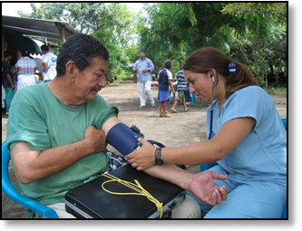
In addition to the programs included in the research, Campus Ministries offers spring break trips to many different locations. Every year, there are one or two trips that go to a Latin American country. The trip destination, information, and price change every year so their information is not included in the research. However, please contact Campus Ministries at GVSU to find out more information about that year’s spring break trips.

[*] This research is part of LAS 399, Independent Study.
Nicaragua
Programa de Innovación (Innovation Program)
GVSU Program: Yes. Study Abroad: Yes, but not through PIC
When: May Duration: Two weeks Approx Cost: $700 + airfare

This program to Nicaragua is organized through Esteli Innovation, an organization started by two Grand Valley Professors. The theme of the trip is innovation, and during the program the student will help run one of the many innovation programs. The philosophy behind the program is the hope education and community leaders achieve their goals. Students will work with six local universities and CENAC, a local language school to further the philosophy. The program has existed for six years and students can arrange to receive GVSU credit for the trip.
Contact Prof. Paul Lane for more information: lanepa@gvsu.edu.

Enhanced Co-op for Engineers
GVSU Program: Yes Study Abroad: Yes, PIC
When: May Duration: Three weeks Approx Cost: $1323 + airfare and tuition

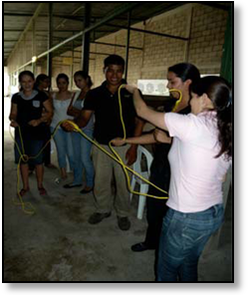
This new faculty-led program is directed at engineering students and will provide for their academic needs and provide cultural immersion in Nicaragua. Students will learn beginner Spanish, live with local-host families, take business and culture classes, work in a local manufacturing company and work with local students to design a build a product to meet a need identified by community members. Students will work with individual businesses and CENAC, a local language school, and Esteli Innovation. Students will receive credit for BUS 301.

Contact Prof. Paul Lane for more information: lanepa@gvsu.edu. Also, check out the information on the PIC website: http://tiny.cc/gvsuengineeringcoop
Medicina Natural
GVSU Program: No Study Abroad: No
When: May-June Duration: Four weeks Approx Cost: $3,250

Through the Universidad Popular de Nicaragua (UPONIC), students can study naturopathic medicine. This program allows students the chance to learn about medicine at the base of the economic pyramid. Working with UPONIC and CENAC, a local language school, students will work in a medical clinic setting, learn clinical Spanish, and Spanish culture. Through UPONIC, student can receive business, culture and Spanish credits. Please note: this program is not associated with Grand Valley.
Contact Prof. Paul Lane for more information: lanepa@gvsu.edu.

Internship Program
GVSU Program: Yes Study Abroad: Yes, but not through PIC
When: Student decides Duration: Student decides Approx Cost: Unknown

This new internship program through Esteli Innovation offers students the chance to complete an internship in Nicaragua. By having an internship, students have a chance to really do something at the base of the economic pyramid and learn culture. Students receive placements to work on projects in Nicaragua based off of their interest. Each internship is unique and depends on the student. Students interested in innovation and engineering will greatly benefit from this internship program with Esteli Innovation in Nicaragua.

Contact Prof. Paul Lane for more information: lanepa@gvsu.edu

International Service Learning
GVSU Program: No Study Abroad: No
When: Many trips Duration: 1-2 weeks Approx Cost: Depends on trip

The International Service Learning (ISL) organization offers many different service trips to Nicaragua and other Latin American countries. In Nicaragua, the main focus of the trips is medical volunteer work. Participants learn how to set up a medical clinic in a village, give a full physical exam, and help to provide medical care for the community. Trips also include sightseeing and cultural experiences for the students. Service learning trips allow students to serve in a foreign country that really needs their help and they also get all the experiences of being in a foreign country.
Please note: In addition to Nicaragua, ISL offers service learning trips to Costa Rica, Dominican Republic, Mexico, Panama, and Peru.

Visit http://www.islonline.org/ for more information.

Psychology Faculty-Led Program
GVSU Program: Yes Study Abroad: Yes, PIC
When: May-June Duration: Three weeks Approx Cost: $2,310 + GVSU tuition

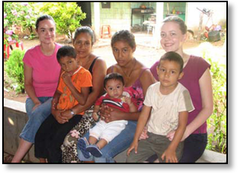
The focus of the program is psychology of social inequality, the unequal distribution of power and resources across class, race, and gender. The faculty-led program is open to all majors. Students will learn about the culture and history of Nicaragua, visit organizations, work on service learning projects, and explore the culture and sites of Nicaragua. The program begins on the GVSU campus where students study psychological research and theory related to inequality within a context of the culture and history of Nicaragua. Students will receive credit for PSY 380.

Contact Prof. Ellen Shupe for more information: shupee@gvsu.edu. Also, check out the information on the PIC website http://tiny.cc/nicaraguapsychology.
Mexico
Spanish Language and Mexican Culture
GVSU Program: Yes Study Abroad: Yes, PIC
When: May-June Duration: 4 ½ weeks Approx Cost: $2,397 + tuition

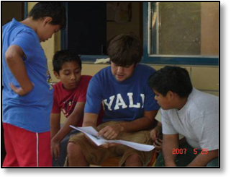
This faculty-led study abroad program conducted by the Department of Modern Languages and Literatures travels to Guadalajara, Mexico. Students take intensive language courses Monday – Friday. Classes occur at the Centro de Estudios para Extranjeros, part of the Universidad de Guadalajara. Students live with local Mexican families. There is a US State Department travel warning for Mexico. Students must read the warning and sign a waiver before applying for the program. Students register for 6 credits while abroad and receive credit for either two SPA 280 courses or two SPA 380 courses.

Contact Prof. Mayra Fortes for more information: fortesm@gvsu.edu. Also, check out the information on the PIC website http://tiny.cc/Mexicolanguageandculture.

Mexican Culture and Education
GVSU Program: Yes Study Abroad: Yes, PIC
When: May Duration: Two weeks Approx Cost: $2,355 + tuition

This program is open to students pursuing a masters in education. The College of Education organizes this program to the Universidad de las Americas en Puebla, Mexico. The program includes culture, education, the arts, archaeology, and several service learning experience. A one week pre-departure orientation is also required that includes lectures, discussions, and readings. Students reside on the campus of Universidad de las Americas. Students receive credit for EDG 601: Mexican Culture and Education.

Contact Prof. Jay Cooper for more information: cooperj@gvsu.edu. Also, check out the information on the PIC website http://tiny.cc/mexicanmasterseducation.
Universidad de las Americas Partnership
GVSU Program: Yes Study Abroad: Yes, PIC
When: Summer, Fall, Winter, Academic Year Approx Cost: $10,295 semester

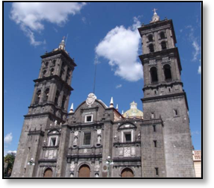
This partnership program allows students from all majors to study abroad in Mexico. The Universidad de las Americas (UDLA) offers many academic programs, with excellent library facilities and the latest technology. UDLA is located in the municipality of San Andres Cholula. The majority of the programs are taught in Spanish, with a limited number taught in English each year. Level of Spanish determines which of these classes students can take. Students can live with a local family or in a residence hall. Students are able to experience and adapt to different cultural norms and expectations through the program and learn Spanish. Transferable class credits vary as there are many courses offered.

Contact the Padnos International Center for more information: www.gvsu.edu/studyabroad. Also, check out the information available on the program at http://tiny.cc/mexicopartnership.

Wellspring Church Mission Trip
GVSU Program: No Study Abroad: No
When: July Duration: 2-3 weeks Approx Cost: $950-$1200

Since 2007, Wellspring Community Church has sent mission teams to Guadalajara, Mexico to work with the Church of the Holy Spirit. Participants work with people in the city, help a local orphanage, and do street ministry. Wellspring Church is located in Hudsonville, MI, close to GVSU’s Allendale campus.
For more information visit http://wellspringcc.org/#/outreach/mexico or contact Wellspring Community Church at wellspringchurch@aol.com and (616) 662-8955.

Mexico Solidarity Network: Study Abroad
GVSU Program: No Study Abroad: Yes, but not PIC
When: Spring, Fall Duration: Semester (14 wk) Approx Cost: Unknown

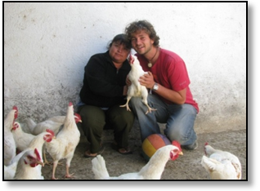
The Mexico Solidarity Network study abroad experience offers students appreciation of the struggles of indigenous communities, campesinos, bracers, and organized sex workers, and autonomous urban organizing around housing and culture. Students can take up to 16 credits at the undergraduate or graduate level, including economics, political science, anthropology, and Spanish. Students also take classes in the community to learn traditional crafts, cooking, medicine and more. The program is accredited by the Universidad Autonoma Metropolitana in Mexico City. Hampshire College is the US school of record and issues formal transcripts.

Visit http://www.mexicosolidarity.org/studyabroad for more information. Also, contact Jeff Smith for more information: jsmith@griid.org.

Dominican Republic
Misión Joven
GVSU Program: No Study Abroad: No
When: Spring Break Duration: One week Approx Cost: $500 + airfare

This trip to Santo Domingo in the Dominican Republic is run by Adelante NYC, Inc. Students do service work in the construction, medical, and education fields. They have the opportunity to work with the poor and impact their lives in many different ways. The program has existed since 1989 and works with many different organizations.

Contact Rev. Joachim Lally for more information: joachiml@ymail.com.

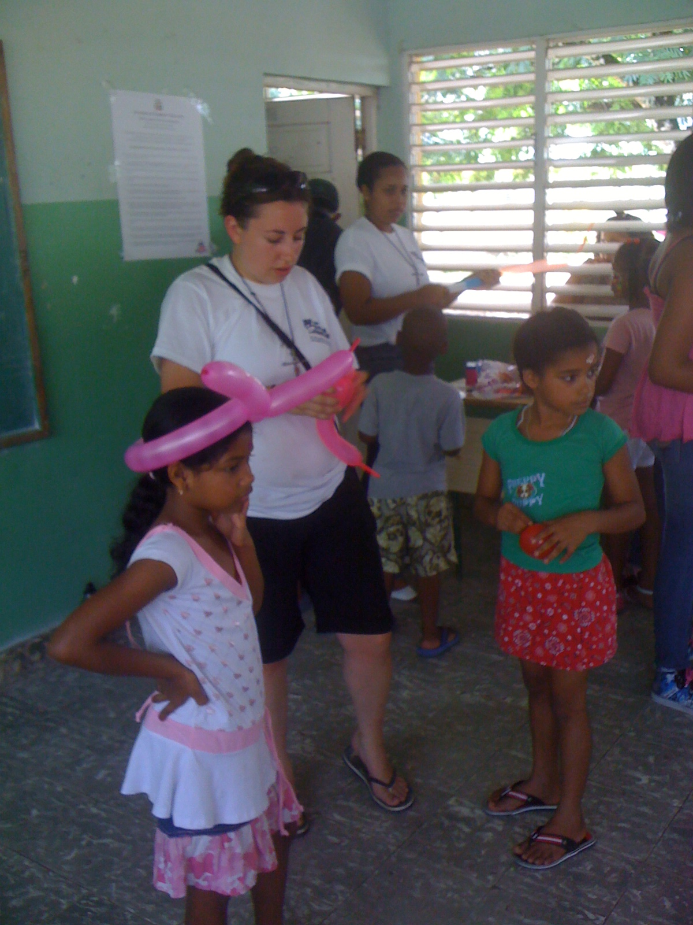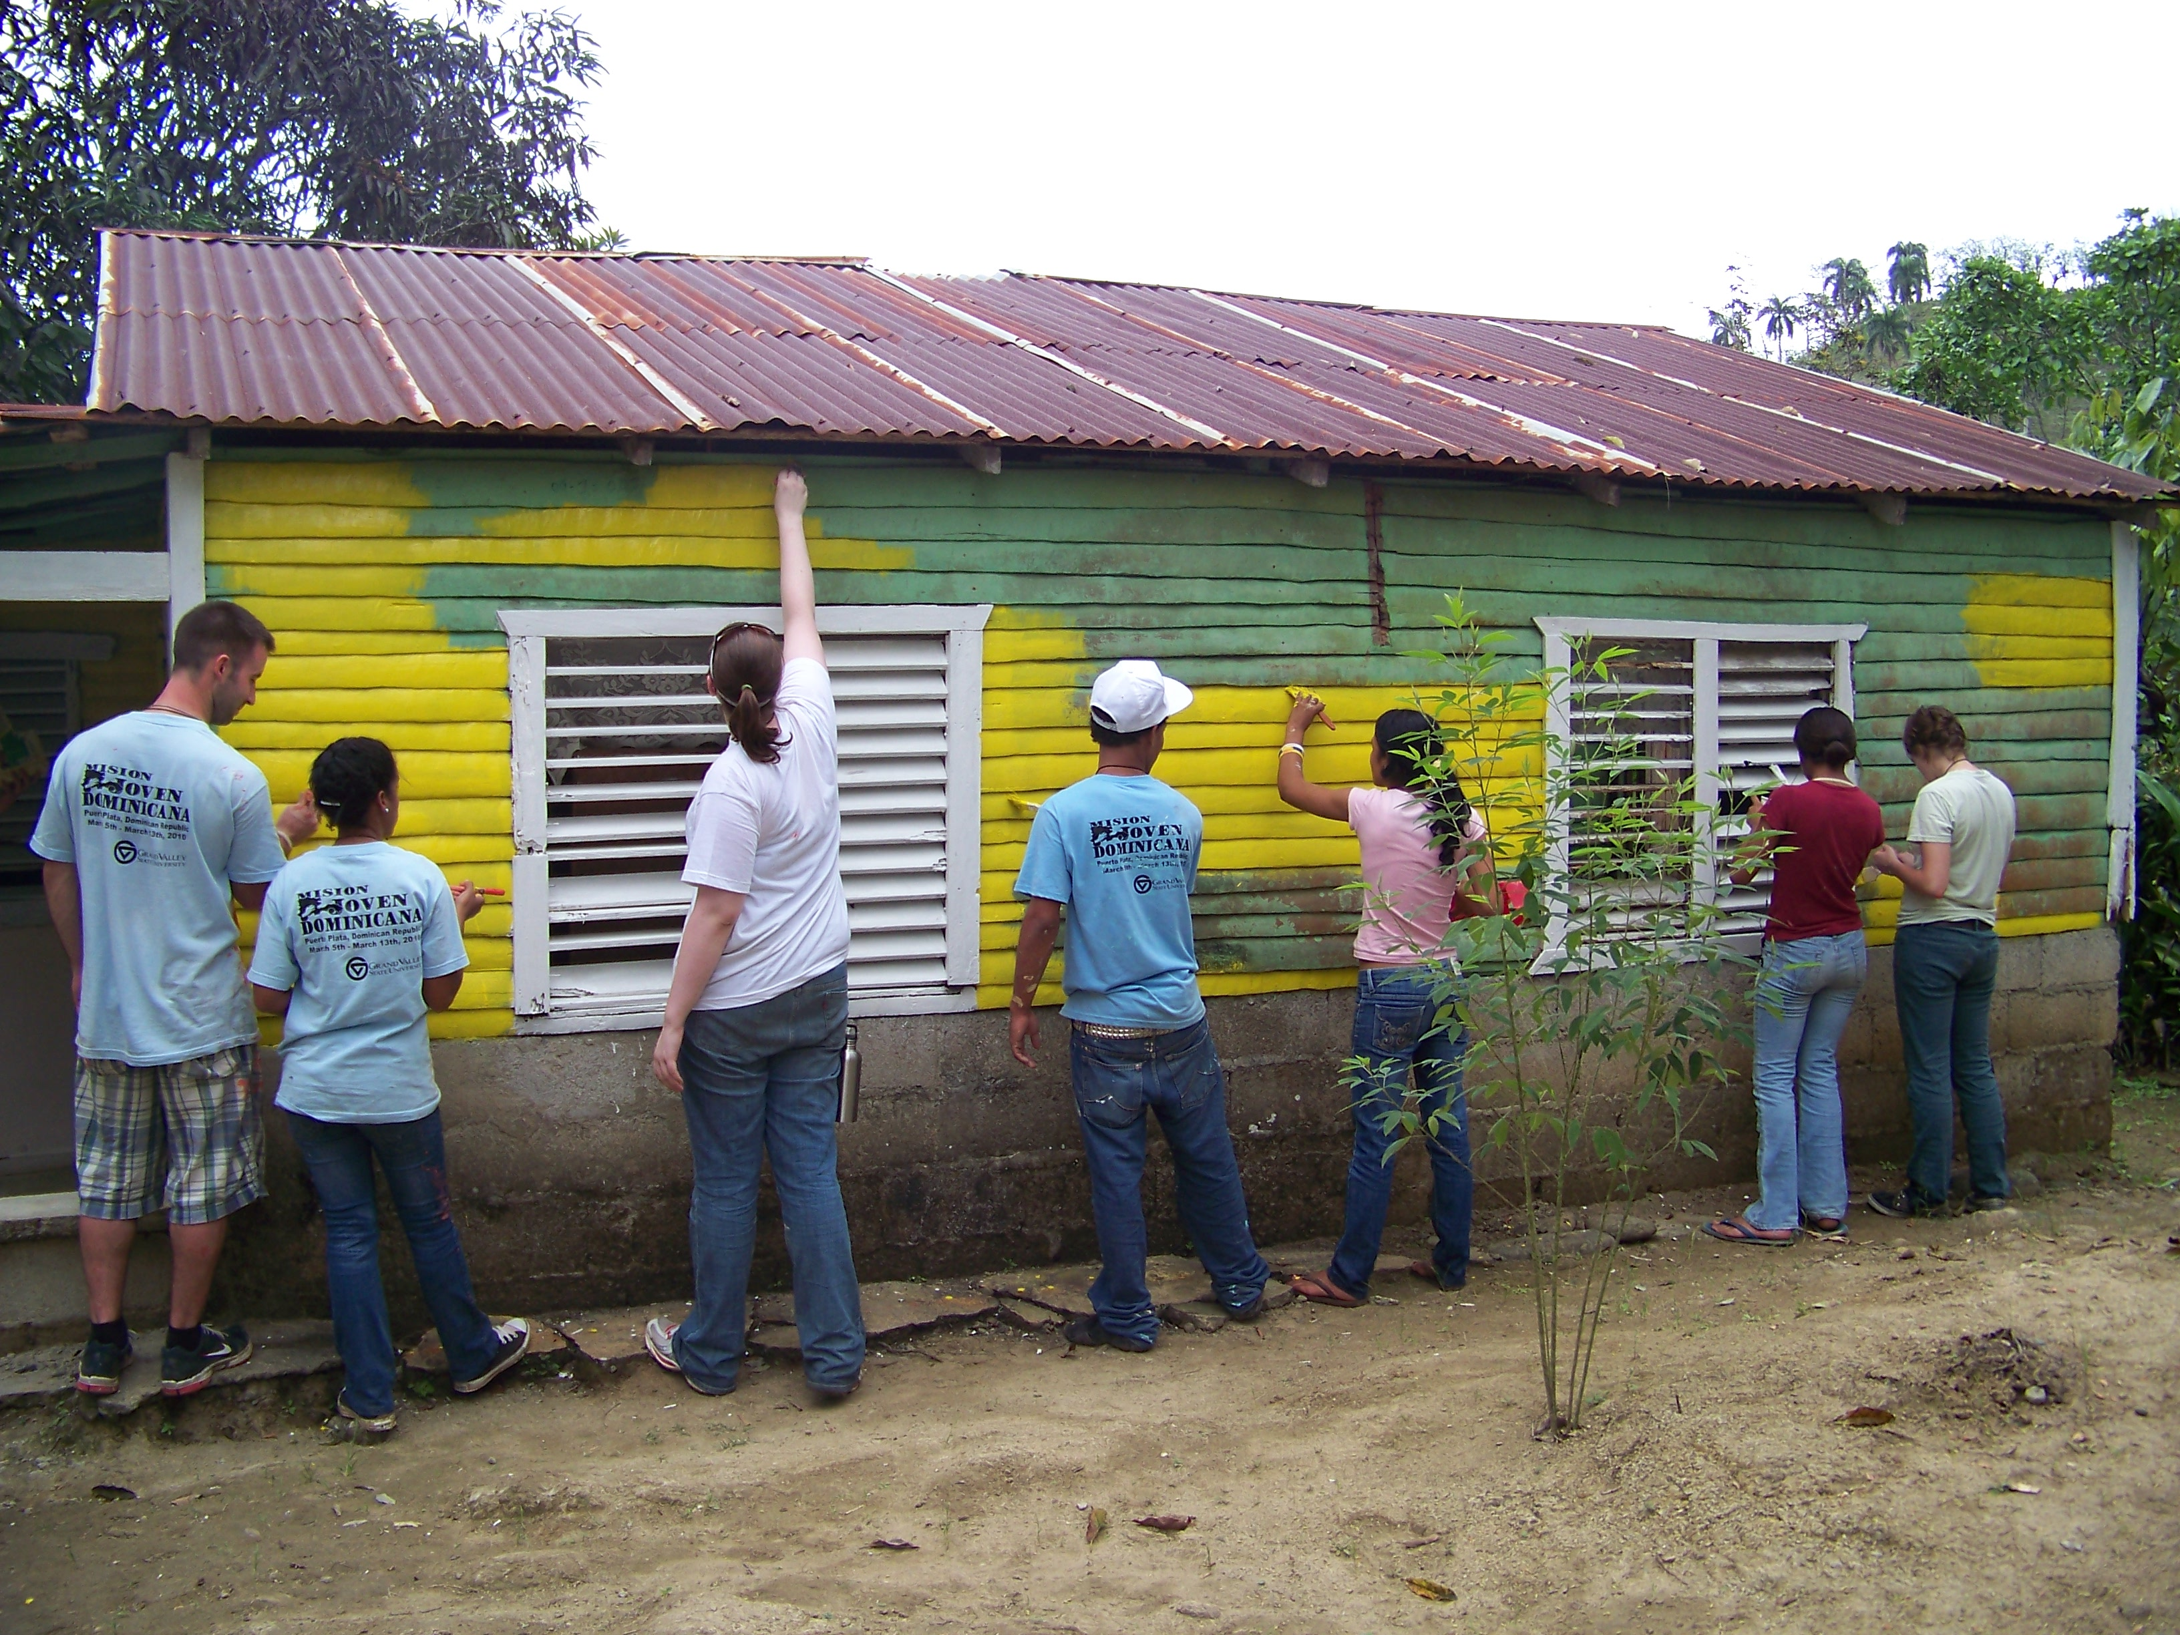

El Salvador
Social Work Program
GVSU Program: Yes Study Abroad: Yes, PIC
When: May Duration: Two weeks Approx Cost: $2,170 + tuition

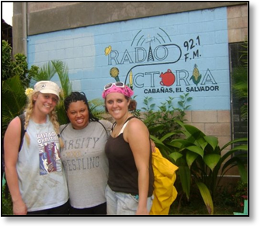
This program is open to undergraduate and graduate social work majors and other students with a genuine interest in Latin America. The goal of the program is to increase one’s awareness of issues of social injustice and human rights as they relate to social work. Students will learn about the rich culture, the political-economic context for social welfare programs, community development, and the role of social workers in El Salvador. . Undergraduate students receive credit for SW 354: International Service and graduate students receive SW 630: Global Service Learning.
Contact Prof. Julie Guevara for more information: guevaraj@gvsu.edu. Also, check out the PIC website for more information: http://tiny.cc/elsalvadorsocialwork.

Honduras
Witness for Peace Program
GVSU Program: No Study Abroad: No
When: Varies Duration: Varies Approx Cost: Varies

Witness for Peace delegations examine the post-coup human rights crisis through meetings with organizations and individuals from a wide sector of Honduran society. Delegations also travel to meet with communities that have been faced with repression by the military or police forces. Must be 15 years old to participate. Please note: In addition, Witness for Peace also offers trips to Colombia, Mexico, and Nicaragua.

Visit http://witnessforpeace.live.radicaldesigns.org/section.php?id=135 for more information. Also, contact Jeff Smith for more information: jsmith@griid.org.

