Sabbatical Showcase and Spring Celebration
Frequently Asked Questions

The Sabbatical Showcase is designed to provide a forum for faculty to share research and creative projects completed during recent sabbatical leaves. Faculty and staff can browse through the exhibits and engage their colleagues, including those outside their departmental focus.
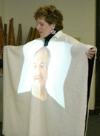
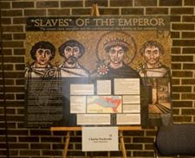
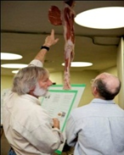
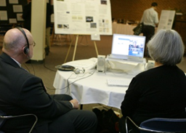
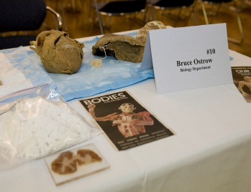

- When is the CLAS Sabbatical Showcase?

The CLAS Sabbatical Showcase is held each spring in conjunction with the College of Liberal Arts and Sciences’ Spring Celebration. This year’s event will take place from 11:00 a.m. - 2:00 p.m. on Wednesday, April 1, 2020 in the Grand River Room (2250 KC). The format of the event is as follows:
11:00 a.m. – 12:00 p.m. Sabbatical Showcase
12:00 p.m. – 1:00 p.m. Spring Celebration Meeting
1:00 p.m. – 2:00 p.m. Sabbatical Showcase

- Who is eligible to participate in the CLAS Sabbatical Showcase?

Tenure track faculty members who have recently completed sabbaticals are eligible to
participate in the event.

- How will I know that I am eligible to participate in this event?

Individuals who are eligible to participate in the CLAS Sabbatical Showcase will receive an e-mail from Roxanne Mol of the CLAS Dean’s Office. E-mails will typically be sent in January of the appropriate semester.

- Who attends the Sabbatical Showcase?

In addition to CLAS faculty and staff, attendees often include university trustees, the GVSU president, the GVSU provost, representatives from University Communications, and members of the CLAS Alumni Board.

- What is expected of me if I agree to participate in this event?

Those who participate in the CLAS Sabbatical Showcase are asked to create displays that express the research and creative activities performed during their sabbaticals. Each presenter is expected to discuss their research with attendees as they peruse the exhibit. In addition, each presenter will submit a 250-word abstract which will be posted in the event
program prior to the event. Please note that all abstracts should be proofread, as they will be published as submitted.

- May I partner with another faculty member during this event?

Yes, presenters may partner with other faculty members during the event.

- What if I would like to participate in the CLAS Sabbatical Showcase, but my discipline does not lend itself toward such an event?

Some faculty members, particularly those in the arts and humanities, believe that their research does not lend itself toward the style of this event. However, in the past, many have discovered creative ways to display their research - even when they doubted that they could. Examples of such displays have included book pages displayed on poster boards, samples of art displayed on tables or walls, music played through headphones, or artifacts displayed on a computer screen. Those with questions surrounding the formatting of their displays are asked to contact either Roxanne Mol (molr@gvsu.edu) or Associate Dean, Kevin Tutt. (tuttk@gvsu.edu)

- What if I am unable to attend the event or cannot attend for the entire time?

CLAS administrators understand that obligations such as teaching may prevent one’s involvement in this event. Individuals who are unable to attend the event throughout its entirety may still participate. However, each participant must be in attendance for at least one session of the event. Those who are unable to do so are encouraged to participate the following year.

- What types of displays are presented at the CLAS Sabbatical Showcase?

Those who participated in the CLAS Sabbatical Showcase during past years provided a wide variety of displays. Examples included posters, videos, music, art, book pages, samples of historic items, and scientific displays. Presenters are encouraged to use their imaginations as they design their displays.

- Who will provide the necessary equipment/supplies for my display?

Depending on the availability of such items, the CLAS Dean’s Office is able to supply a number of items including easels, tables, televisions, electrical outlets, and extension cords in limited quantity. Computers, monitors, stereos, and other items must be supplied by participants. Please feel free to contact Roxanne Mol with questions surrounding the availability of equipment.

- Who is responsible for covering the cost of my material?

The CLAS Dean’s Office will cover the cost of all equipment that it provides. All other costs must be covered by either the presenter or their department.

- Are there any specifications surrounding my poster?

The College of Liberal Arts and Sciences grants each participant the freedom to design their display as they choose. Therefore, poster sizes are not specified but are typically approximately 3’ x 4’ in dimension. More than one poster may be displayed by any presenter. The College will supply easels for each poster displayed. However, please note that presenters must provide their own posters with supportive backing.

- How will I communicate with the CLAS Dean’s Office regarding my needs or intentions?

The CLAS Sabbatical Showcase website (http://gvsu.edu/clas/sabbatical-showcase-90.htm) contains a link to an electronic form. All information should be submitted via the electronic form. Information on the site will be downloaded and processed by Roxanne Mol.

- Whom should I contact if I have questions regarding this event?

Questions pertaining to the CLAS Sabbatical Showcase may be referred to either Roxanne Mol (molr@gvsu.edu) or Associate Dean, Kevin Tutt (tuttk@gvsu.edu).

