Syllabus%20Ahead.pdf

Out of the Box 2018

**Join us!**

This year’s Out of the Box event is a workshop format, intended to help interested faculty get started on collaborative teaching projects.

DATE: February 6 or 7  
TIME: 11AM-1PM  
LOCATION: 2215/2216 KC



**Interested in Collaborative Teaching….**

**But don’t know where to start??**

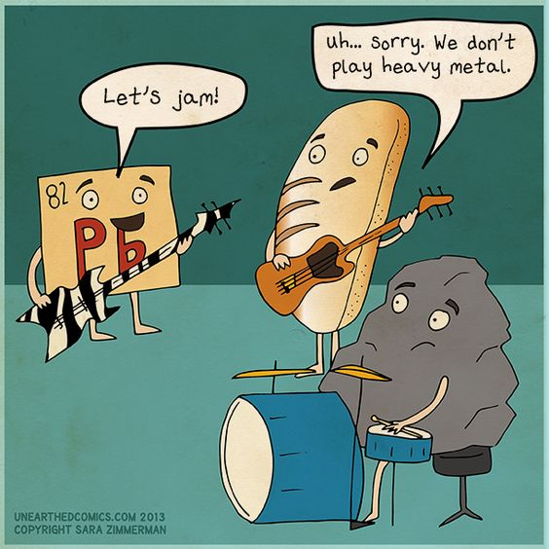

*Collaborative teaching* benefits both students and faculty when disciplinary problems and perspectives are effectively integrated. While co-teaching is the most recognizable form of collaborative teaching, there are numerous other models that entail varying levels of collaborative practices. But it is often difficult to know where to start…

At this year’s Out of the Box workshop, the Faculty Council and FTLC will help interested faculty navigate the challenges involved in building an effective collaboration that successfully integrates different disciplinary and pedagogical approaches.

**Collaborative Teaching**

**Models Include:**

* *Co-teaching*—sharing instructor duties in the same class
* *Co-requisite*—linking two separate classes where students enroll in both
* *Cross-listing*—two separate classes that meet at the same day/time and occasionally meet together
* *Guest lectures*—adding expertise to the topic either in person or as a digital guest
* *Combined assignments*—students in two separate classes collaborate on joint assignments as part of their course requirements
* *Workshops/conferences*—students share presentations in other classes
* And so many more!

**Interested in learning more?**

Fill out and detach this section so we can best prepare the February Out of the Box workshop. Send to Heather Van Wormer, LMH 221.

Name______________________

Department_________________

Email_______________________

Collaborative teaching topic of

interest ____________________

Already have a partner in mind?

Yes No

Name_______________________

 Models that interest you (if you know):

Co-teaching

Co-requisite

Cross-listing

Guest lectures

Combined assignments

Workshops/conferences