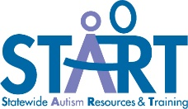
Peer to Peer Support Program

Student with ASD Survey – Middle or High School
*Complete at the END of the school year after participating in a Peer to Peer Program

Today’s date:
Name:
Grade:
Name of school building:
Name of school district:
I am in a peer to peer program: Yes No
Date you started in the peer to peer support program:

Instructions: Answer the questions by marking very true, sort of true, or not very true for each question. | Very true | Sort of true | Not very true
- I talk to other people about autism.
- I like school.
- I participate in class.
- I have friends at school.
- I eat lunch with friends.
- I walk to class with friends.
- I go places with friends after school or on the weekend.
- Kids at school understand me.
- My teachers understand how to help me.
- I can ask for help from other kids.
- I talk to my family about what happens at school.
- I like being part of the peer program at my school.

