Step 1: Open the GVSU website and choose the compass icon located in the top right-hand corner to open Navigate.
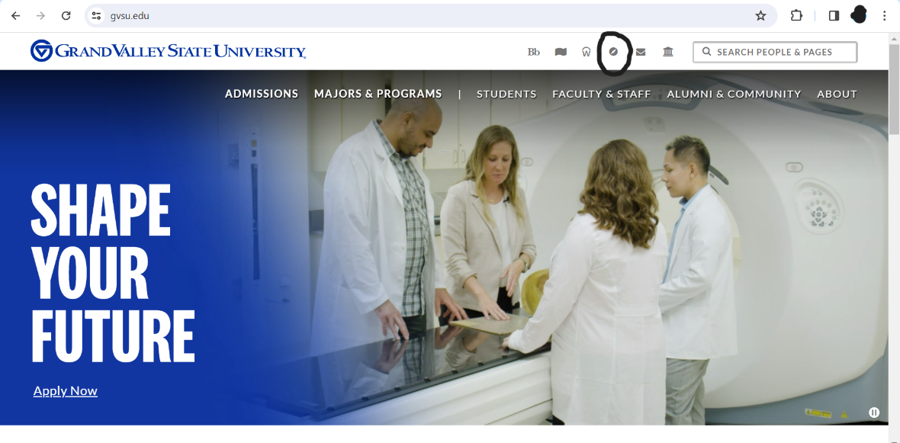
Step 2: Log into Navigate using your GVSU student information.
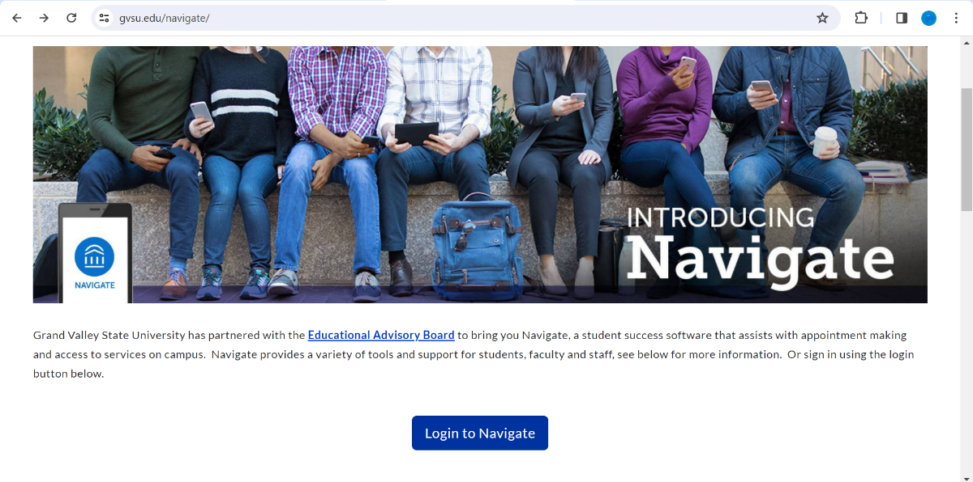

Step 3: On the home screen, select "Schedule an appointment" located on the right-hand side of the screen.
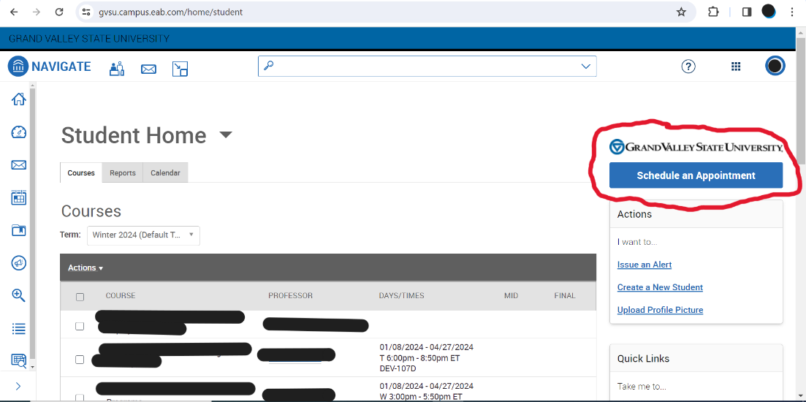
Step 4: Then you will fill out the following questions about which office, service and date you would like to set up an appointment for. For SASC, the office you’ll select “Student Academic Success Center.” Then click on "find available time."
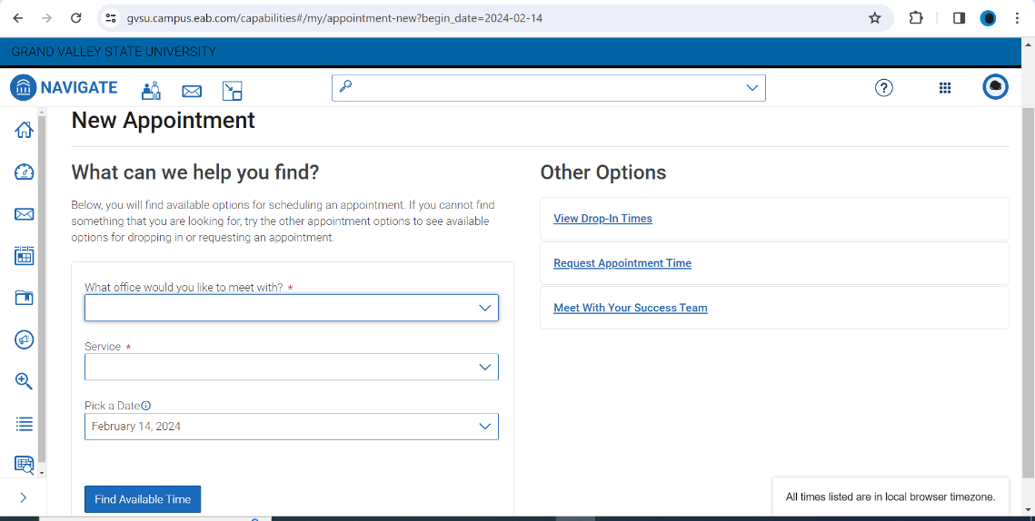

Step 5: From there, you will select a time that works best for you and a professional that you would like to meet with.
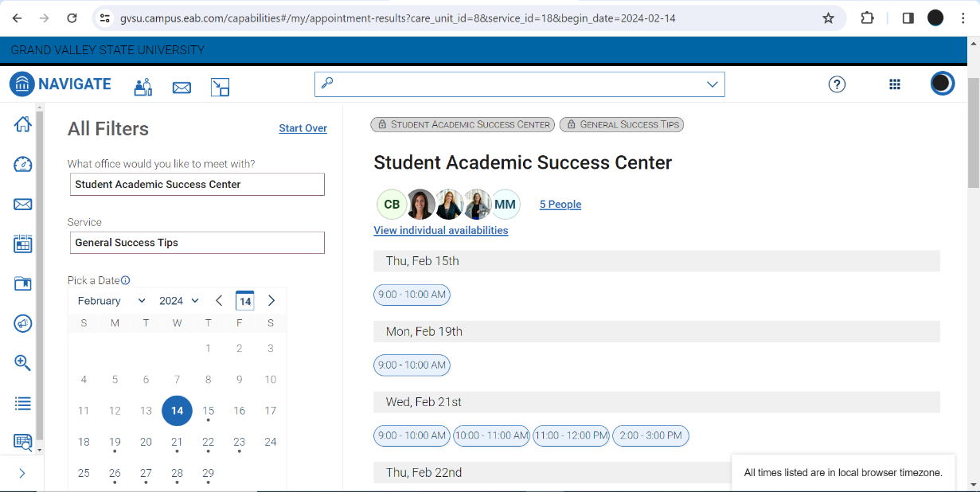
Step 6: After you completed making an appointment, you will get a confirmation email for your appointment.

