

October 18, 2013

To: Prospective Bidder

Subject: Resubmission Requested Bid #213-35 (2)
Please resubmit your proposal to include updated prevailing wage rates for Grand Rapids MI and Traverse City MI

Grand Valley State University is accepting proposals for an Integrated Video Conference System for our Seidman College of Business. Reference attached instructions and specifications.

If you wish to bid on this equipment, please submit your proposal for bid #213-35 no later than 10:00 AM on Thursday, October 24, 2013. E-mail your proposal to: RFP-Received@gvsu.edu

Submit your proposal electronically to the above e-mail address by the bid opening date and time. Grand Valley State University is not responsible for e-mail bids affected by spam or not received by the bid opening date & time. No fax, verbal, or telephone proposals will be accepted.

Before submitting proposal, check to be sure that:

- The Proposal/Certification/Contract form is signed and witnessed.
- All addenda received are acknowledged

Note: Electronic submission becomes your authorized signature

Thank you for your participation,

Valerie Rhodes-Sorrelle, C.P.M.
Senior Strategic Sourcing Specialist

Purchasing Services - 227 Lake Michigan Hall - Allendale, MI 49401

Phone - 616/331-2283 - Fax 616/331-3287



INTRODUCTION

Grand Valley State University, established in 1960, is a four-year public university. It attracts more than 24,500 students with its high quality programs and state-of-the-art facilities. Grand Valley provides a fully accredited undergraduate and graduate liberal education and has campuses in Allendale, Grand Rapids, and Holland and centers in Muskegon and Traverse City. Grand Valley is the comprehensive regional university for the state's second largest metropolitan area and offers 81 undergraduate and 29 graduate degree programs. The university is dedicated to individual student achievement, going beyond the traditional classroom experience, with research opportunities and business partnerships. This combination of educational offerings helps Grand Valley to fulfill its mission of educating students to shape their lives, their professions, and their societies.

As a model for sustainable development, Grand Valley State University fosters responsible economic growth. First-rate faculty and staff, who are attracted to the university's rich academic culture, liberal education, and state-of-the-art facilities, share their expertise, their time, and their knowledge with students. The university's outstanding students learn critical thinking skills and are transformed into enterprising individuals who are well prepared to take leadership roles in their professions and in their communities. The university community comes together to make Grand Valley a significant force on the area's economy.

Grand Valley's growth in size and prestige contributes to continued economic growth in the entire region. Grand Valley's more than 27,500 students, faculty and staff made a total estimated impact of $680.4 million in Kent, Ottawa, and Muskegon counties during fiscal year 2009-2010. This reflects the ripple effect of university, employee and student expenditures, and related job creation in the area. In that year, more than 6,811 students participated in internships, practica, and student teaching, potentially saving area organizations some $25 million. Grand Valley Community members participated in more than 920,000 hours of volunteer service work last year.

Grand Valley represents top performance and top value. The university has been recognized for 16 straight years as one of "America's 100 Best College Buys" because of the high-quality education opportunities it provides at an affordable tuition rate. Grand Valley State has been listed as one of America's top colleges in 2011 Forbes Magazine and The Princeton Review named Grand Valley as one of the best Universities in the Midwest.

Integrated Video Conference System

Statement of Need
Grand Valley State University (GVSU) is requesting competitive written proposals from qualified organizations for the integration of a video conferencing system into two existing classrooms. One to be located in GVSU’s Cook-DeVos Center for Health Sciences, Room 145 and the other in Northwestern Michigan College’s (NMC) University Center, Room 09. Each system will integrate with the existing classroom audio visual equipment as provided by GVSU and have the capability to connect with each other as well as with the outside world via an H.323 telepresence codec.

By issuing this RFP and collecting responses for an Integrated Video Conference System, GVSU is not under any obligation to accept proposals or to proceed with the purchase of the equipment and services requested, and reserves the right to reject any or all proposals. Questions concerning the RFP should be directed to John Klein, Associate Director of Academic Services.

Grand Valley State University
Specifications
Bid #213-35(2)

GVSU CHS 145 Integrated Video Conference System Requirements:

TelePresence Codec
1- IP based end-to-end high definition video conferencing solution with dual stream support, full duplex audio and embedded multi-point functionality.
Recommended Component: Cisco TelePresence System Codec 90

Recording Device
1- Appliance-based telepresence content server capable of recording and streaming video and H.239 dual-stream presentations from any H.323 or Session Initiation Protocol (SIP) video conferencing unit. Compatible with all major streaming formats, including Windows Media, Flash, and QuickTime with support for download of content to PC, Mac, and portable media devices.
Recommended Component: Cisco TelePresence Content Server

Instructor Camera System
1- Full 1080/20 HD resolution PTZ camera with 20x optical zoom lens and RS-232C/RS-422 interface protocol. Featuring full auto focus, auto iris and auto white balance abilities.
Recommended Component: Sony HD Pan/Tilt Camera EVI-H100V/W

NOTE: Provide “optional” pricing for automated instructor tracking camera or system.

Student Camera System
2- Full 1080/20 HD resolution PTZ camera with 20x optical zoom lens and RS-232C/RS-422 interface protocol. Featuring full auto focus, auto iris and auto white balance abilities.
Recommended Component: Sony HD Pan/Tilt Camera EVI-H100V/W

Instructor Microphone
1- Surface-mounted electret condenser boundary microphone designed for mounting on a lectern with high sensitivity and a wide frequency range.
Recommended Component: Shure MX392/C Condenser Boundary Microphone

Wireless Microphone System
1- Combo wireless microphone system including wireless bodypack transmitter, handheld transmitter and single channel diversity receiver.
Recommended Component: Shure SLX124/85/SM58

Student Microphone System
3- Ceiling mounted microphone array featuring three wide-range microphones mounted together into a single unit array, providing the rich sound of three individual unidirectional microphones while maintaining full 360 degree coverage.
Recommended Component: ClearOne Ceiling Microphone Array

Student Display System
2- High Definition 60-inch 1080p LED-LCD TV with video-enhanced refresh rate-120 Hz. One display for remote site video (camera) and one display for remote site content.
Recommended Component: Sharp LC-60LE640U 60" HD Flat Panel Display

NMC UC-09 Integrated Video Conference System Requirements:

TelePresence Codec
1- IP based end-to-end high definition video conferencing solution with dual stream support, full duplex audio and embedded multi-point functionality.
Recommended Component: Cisco TelePresence System Codec 90

Instructor Camera System
1- Full 1080/20 HD resolution PTZ camera with 20x optical zoom lens and RS-232C/RS-422 interface protocol. Featuring full auto focus, auto iris and auto white balance abilities.
Recommended Component: Sony HD Pan/Tilt Camera EVI-H100V/W

NOTE: Provide optional pricing for automated instructor tracking camera or system.

Student Camera System
1- Full 1080/20 HD resolution PTZ camera with 20x optical zoom lens and RS-232C/RS-422 interface protocol. Featuring full auto focus, auto iris and auto white balance abilities.
Recommended Component: Sony HD Pan/Tilt Camera EVI-H100V/W

Instructor Microphone
1- Surface-mounted electret condenser boundary microphone designed for mounting on a lectern with high sensitivity and a wide frequency range.
Recommended Component: Shure MX392/C Condenser Boundary Microphone

Wireless Microphone System
1- Combo wireless microphone system including wireless bodypack transmitter, handheld transmitter and single channel diversity receiver.
Recommended Component: Shure SLX124/85/SM58

Student Microphone System
2- Ceiling mounted microphone array featuring three wide-range microphones mounted together into a single unit array, providing the rich sound of three individual unidirectional microphones while maintaining full 360 degree coverage.
Recommended Component: ClearOne Ceiling Microphone Array

Student Display System
2- High Definition 60-inch 1080p LED-LCD TV with video-enhanced refresh rate-120 Hz. One display for remote site video (camera) and one display for remote site content.
Recommended Component: Sharp LC-60LE640U 60" HD Flat Panel Display

Installation
- The vendor is to act as system integrator and equipment installer for all of the above listed equipment. Installation to include all necessary hardware, cabling, connectors and miscellaneous components required to complete a fully functioning system, including any items which are not listed in the RFP.

- The vendor will team with GVSU to ensure that all of the above listed equipment will fully integrate with all of the owner supplied classroom audio visual equipment (see Appendix A-F). The owner supplied equipment may also be upgraded prior to the system’s installation and may include HDMI compatible sources. Vendor should factor in the ability to integrate HDMI sources into the system as part of their proposal.

- All installed cabling should be clearly labeled, include an appropriate service loop and must be properly grounded where applicable.

- The vendor will ensure that the installation is performed in accordance with applicable specifications, codes and standards and to insure that all work performed is in accordance with the requirements of all local codes and regulations of the authorities having jurisdiction.

- The vendor shall not disturb any cabling, wiring, equipment, miscellaneous hardware and work installed by others unless it is necessary for the performance of the vendor’s work. If it is necessary, any equipment or work disturbed shall be coordinated with the affected provider in advance and then restored to the same complete and functioning condition as it was in before the disturbance.

Maintenance Agreement
- Vendor shall provide pricing options on all manufacturer service and maintenance requirements as well as available vendor provided basic, full and enhanced level maintenance service agreements as a yearly cost for 1, 3 and 5 years.

Warranty
- Vendor shall identify their warranty, manufacturer’s warranty, and system integration warranty.

Documentation
- Vendor shall provide a complete set of operator’s manuals, as built drawings with clearly identified cabling and equipment, and specifications by location.

Electrical and Network Requirements
- Vendor shall provide any necessary technical requirements including electrical and network requirements to support the proposed systems.

Training
- Vendor shall provide training on operation and basic maintenance procedures for the buyer’s designated personnel.

Testing and Acceptance
- All sites must be fully tested and operable prior to acceptance.

Past Performance
- Vendor shall submit references from 3 customers of like size. Provide current contact information to include name, phone number, e-mail, company name and description of the project.

Pricing and Payment Schedule
- Vendor shall separate and itemize pricing for each component and service provided by room. GVSU reserves the right to eliminate either or both locations from consideration as part of this request.

- Vendor shall propose a payment schedule.

- If there are any cost saving measures or alternative equipment options that will allow for improvements in the design and/or allow for future expansion, then those recommendations are encouraged.

- All equipment and material specified herein are recommended brand names and models. If a vendor is providing a price proposal for equipment equal to that specified, they must clearly identify the equipment by manufacturer and model number and must supply equipment and model specific technical data sheets (cut sheets) for the equipment proposed.

Grand Valley State University
Information & Instructions to Bidders

Bid #213-35(2)

- Grand Valley State University’s sales tax exempt no. 381684280

- Quote prices F.O.B. delivered to Grand Valley State University. Exact campus location will be given on purchase order submitted to supplier – F.O.B. delivered to GVSU = no shipping, freight, fuel surcharges or handling charges added to any invoice pertaining to this bid.

- Grand Valley State University is not responsible for hazardous material charges unless indicated in your proposal

- Reference attached Specifications

- Proposal submission:
If you specialize in the type of equipment and the services identified in the statement of need, specifications, and are interested in providing these services & equipment please submit your proposal for bid #213-35(2) no later than 10:00 AM on Thursday, October 24, 2013. E-mail your proposal to: RFP-Received@gvsu.edu

- Grand Valley State University reserves the right to accept alternate equipment that meet and or exceeds attached specifications. Include with your quotation any supporting documentation (pictures and written specifications) that might help us in our decision making process.

- Provide product availability

- Provide warranty information

- Grand Valley State University reserves the right to award bids / proposals in the manner that will best suit the University.

- Once an award has been made, no product substitutions will be accepted. Delivery of any substitutes will be refused and/or returned at the supplier’s expense.

- Grand Valley State University is requesting guaranteed pricing for 90 days after the bid opening date. Please indicate expiration date of your quotation on bid.

- At Grand Valley State University, socially responsible procurement -- which is defined as supporting diversity, socially responsible procurement, and sustainability -- is highly valued. These ideals are fundamental to our academic, research, and athletic excellence. GVSU promotes supplier participation that is reflective of the diverse business community and of the University's desire to procure environmentally friendly products, while remaining focused on socially responsible procurement methodologies.

- Grand Valley State University endeavors to buy products made in the United States of America whenever an American-made* product is available that meets or exceeds the specifications requested and the price is equal to or lower than a foreign-made product. Vendors are requested to bid American-made products and or services whenever available. Vendors may bid foreign-made products or services when:

- They are specified
- They are identified as an alternate by the vendor as long as they are technically acceptable.
*More than 50% of the manufactured or assembled in the United States.

14. Grand Valley State University reserves the right to accept or reject any or all bids.

Grand Valley State University reserves the right to accept any item or your entire proposal at the price quoted unless other wise indicated by you.

15. The University reserves the right to conduct discussions, request additional information and accept revisions of proposals from any or all bidders. The University reserves the right to negotiate with the bidder whose proposal is deemed most favorable.

16. Contact John Klein with question regarding bid specifications at 616-331-2777and Valerie Rhodes-Sorrelle with any questions concerning this bid terms and conditions at 616/331-2283.

General Terms and Conditions (Rev. 04.2013)

  - Supplemental Conditions

    - The Supplier shall comply with the University’s policy and procedures (http://www.gvsu.edu/purchasing) and any additional instructions issued from time to time by the University.

    - During the period of contract, no change is permitted to any of its conditions and specifications unless the Supplier receives prior written approval from the University.

    - Should the Firm find at any time that existing conditions make modification in contract requirements necessary, it shall promptly report such matter to the University for its consideration and decision.

    - The Firm shall comply with any and all federal, state or local laws, now in effect or hereafter promulgated which apply to the operation herein specified.

    - The Firm’s performance may be evaluated by a designee or an Advisory Committee of the University meeting from time-to-time during the period of contract. It will be the responsibility of the Firm to respond, in writing if so requested, to inquiries, requests for change, and recommendations.

    - The Firm shall provide the University, with telephone numbers and addresses of management personnel and shall arrange for at least one such person to be available during the University’s normal working hours by telephone. The Firm shall also provide sufficient backup in times of staff shortages due to vacations, illnesses, and inclement weather.

    - The Firm shall maintain applicable insurance coverage with appropriate coverage limits. The Firm shall provide the name of the primary insurance carrier and their trade rating which may apply to the operation herein specified.

  - Termination

The University may terminate this agreement for any reason, including but not limited to, changes in the market price of the products and non-appropriation of federal or state funding to university, by delivering not less than thirty days prior written notice to Supplier.

If termination is due to default by Supplier, Supplier shall have ten days from receipt of notice to cure the default. If Supplier fails to cure within the ten-day period, university may terminate this agreement immediately.

The failure of university to exercise its rights of termination for default due to Suppliers failure to perform as required in any one instance shall not constitute a waiver of termination rights in any other instance.

  - General Terms and Conditions

The terms and conditions shall govern any agreement issued as a result of this solicitation.

Additional or attached terms and conditions which are determined to be unacceptable to the University may result in the disqualification of proposals. Examples include, but are not limited to: liability for payment of taxes, subjugation to the laws of another state, and limitations on remedies.

4.3.1 Interpretation, Enforcement and Forum of Laws

For disputes between University and Supplier, this agreement shall be governed by, construed, interpreted, and enforced solely in accordance with the laws of the State of Michigan and the venue of any action shall lie in such state.

4.3.2 Compliance with Law

Supplier warrants and certifies that in the performance of this agreement, it has complied with or will comply with all applicable statutes, rules, regulations and orders of the United States, and any state or political subdivision thereof, including but not limited to, laws and regulations pertaining to labor, wages, hours and other conditions of employment.

4.3.3 Funding Provided by Federal Contracts or Grants

Where federal contracts or grants provide funding to University, it is the responsibility of the Supplier and University to comply with all FAR (Federal Acquisition Regulations) applicable laws and regulations by completing any certifications and disclosures and any other requirements. When federal contract or grant funds are used on purchases under this agreement, which exceed $25,000, certification must be provided in writing that the Supplier is not debarred, suspended, or proposed for debarment by the Federal Government.

4.3.4 Insolvency

In the event of any proceedings in bankruptcy or insolvency by or against Supplier, or in the event of the appointment (with or without it’s consent) of an assignee for the benefit of creditors, or a receiver, University may cancel this agreement without prior notice and without incurring any liability whatsoever to Supplier.

4.3.5 Assignments

Supplier shall not assign this agreement or any of Supplier’s rights or obligations hereunder, without University’s prior written consent. Any purported assignment made without prior written consent shall be void and of no effect.

    - Patent Trademark and Copyright Infringement

The Supplier warrants that the products/services hereby sold, either alone or in combination with other materials, do not infringe upon or violate any patent, copyright, trademark, trade secret, application or any other proprietary right of any third party existing under laws of the United States or any foreign country. The Supplier agrees, at its own expense, to defend any and all actions or suits alleging such infringements and will hold University, its officers, agents, servants, and employees harmless from any and all losses, expenses, claims, (including reasonable attorney’s fees), or judgments arising out of cases of such infringement.

4.3.7 Use of Name, Logos, etc. in Advertising

Supplier agrees not to make reference to this agreement or use University logo or trademarks in any advertising material of any kind without expressed written permission. University agrees not to make reference to this agreement or use the logo of Supplier in any advertising and marketing materials of any kind without the expressed written permission of the Supplier.

4.3.8 Indemnification

Supplier agrees to indemnify and hold University harmless from and against all liability, losses, damages, claims, liens, and expenses (including reasonable legal fees) arising out of or connected with the products purchased, work or services performed, or resulting from damages or injuries incurred by or to University by reason of any defect in manufacture, construction, inspection, delivery, material, workmanship, and/or design of any goods and services furnished hereunder, excepting only such liability as may result solely from the acts of negligence of University or its employees. Supplier, at the request of University, shall undertake to defend any and all suits and to investigate and defend any and all claims whether justified or not, if such claim or suit is commenced against University or its respective officers, agents, servants, and employees.

4.3.9 Insurance

If fabrication, construction, installation, service or other work is specified to be conducted on University premises, Supplier shall maintain in force during the period of such work limits of liability as required by law or as set forth herein, whichever is greater: (a) worker’s compensation, as required by the laws of the State of Michigan; (b) commercial general liability for bodily injury and/or property damage in an amount of not less than $1,000,000 single limit, per occurrence; (c) automobile liability for bodily injury and/or property damage in an amount of not less than $1,000,000 single limit, per occurrence. Supplier shall provide a certificate of insurance naming University as additional insured. Supplier shall furnish to University satisfactory proof of such insurance coverage included with Supplier’s proposal.
4.3.10 Licenses/Permits/Taxes and Tax Exempt Status

Supplier shall be responsible for obtaining all permits, licenses and bonding, to comply with the rules and regulations of any state, federal, municipal or county laws or any city government, bureau or department applicable and assume all liability for all applicable taxes.

University is a 501(c) (3) not-for-profit corporation and is exempt from state sales and use taxes imposed for services rendered and products, equipment or parts supplied.

All prices listed and discounts offered are exclusive of sales and use taxes. Supplier has the duty to collect all taxes in connection with the sale, delivery or use of any items, products or services included herein from University (if for the purpose of resale), at the taxable rate in effect at the time of invoicing. Supplier shall comply with the tax requirements of the State of Michigan. University shall furnish to Supplier a certificate of exemption in form and timeliness acceptable to the applicable taxing authority.

4.3.11 Americans with Disabilities Act

Supplier shall comply with all applicable provisions of the Americans with Disabilities Act and applicable federal regulations under the Act.

4.3.12 Alcohol, Tobacco & Drug Rules and Regulations

Employees of the Supplier and its subcontractors shall comply with all instructions, pertaining to conduct and building regulations of the University. University reserves the right to request the removal or replacement of any undesirable employee at any time.

All buildings at all University locations are tobacco-free. Use of tobacco products is not permitted in any area inside any buildings. Smoking is prohibited within twenty-five (25) feet of any building, within twenty-five feet of any bus stop on University property and within twenty-five feet of the Little Mac Bridge on the Allendale campus. The Supplier is expected to respect this tobacco-free policy and fully comply with it.

The Supplier agrees that in the performance of this agreement, neither the Supplier nor any of its employees shall engage in the unlawful manufacture, distribution, dispensing, possession, or use of a controlled substance, including alcohol, in conducting any activity covered by this agreement. University reserves the right to request a copy of the Drug Free Workplace Policy. The Supplier further agrees to insert a provision similar to this statement in all subcontracts for services required.

4.3.13 Equal Opportunity

The provisions of Section 202 of Executive Order 11246.41 C.F.R. Sec. 60-1.1 C.F.R. Sec. 60-250.4 and 41 C.F.R. Sec. 60-741.4 are incorporated herein by reference and shall be applicable to this agreement unless this agreement is exempted under the rules, regulations, or orders of the U.S. Secretary of Labor.

4.3.14 Non-Discrimination

The parties agree to comply with applicable state and federal rules governing Equal Employment Opportunity and Non-Discrimination.

4.3.15 Sexual Harassment and Bias Incidents

Federal law and the policies of the University prohibit sexual harassment. Supplier is required to exercise control over its employees so as to prohibit acts of sexual harassment. If University in its reasonable judgment determines that any employee of Supplier has committed an act of sexual harassment, Supplier agrees as a term and condition of this agreement to cause such person to be removed from University’s facility and to take such other action as may be reasonably necessary to cause the sexual harassment to cease.

4.3.16 Compliance with Specifications

The Supplier warrants that all goods, services, or work supplied under this agreement shall conform to specifications, drawings, samples, or other descriptions contained or referenced herein and shall be merchantable, of good quality and workmanship and free from defect. The Supplier also warrants that all goods covered by this agreement which are the product of the Supplier or are in accordance with its specifications, will be fit and subject to University inspection before acceptance, and also to later rejection if use reveals defects not apparent upon receipt; and if rejected will be held at Supplier’s risk and expense for storage and other charges after 60 days of storage, goods may be disposed of without cost to University. Neither receipt of goods nor payment therefore shall constitute a waiver of this provision.

4.3.17 Gratuities

University may, by written notice to Supplier, cancel the agreement if it discovers that gratuities, in the form of entertainment, gifts or the like, were offered or given by Supplier to any officer or employee of University with a view toward securing an agreement or securing favorable treatment with respect to the awarding of this agreement.

4.3.18 Covenant Against Contingency Fees

Supplier certifies that it has neither offered nor paid a contingency fee to any individual, agent, or employee of University to secure or influence the decision to award this agreement to Supplier.

4.3.19 Suspension or Debarment

University may, by written notice to the Supplier, immediately terminate the agreement if it is determined that the Supplier has been debarred, suspended or otherwise lawfully prohibited from participating in any public procurement activity, including but not limited to, being disapproved as a subcontractor by any public procurement unit or other governmental body.

4.3.20 Conflict of Interest

In order to avoid even the appearance of any conflict of interest, neither University nor Supplier shall employ any officer or employee of the other party for a period of one year from the date hereof.

4.3.21 Strikes or Lockouts

In the event Supplier should become involved in a labor dispute, strike or lockout, Supplier will be required to make whatever arrangements that may be necessary to insure that the conditions of this agreement are met in their entirety. Should the Supplier be unable to fulfill its obligations under this agreement, University shall have the right to make alternative arrangements to insure the satisfactory performance of the agreement during the time Supplier is unable to perform the required duties. Any costs incurred by University, as a result of such job action, shall be reimbursed by the Supplier.

4.3.22 Force Majeure

Neither party shall be held responsible for any losses resulting if the fulfillment of any terms or provisions of this agreement are delayed or prevented by any cause not within the control of the party whose performance is interfered with, and which by the exercise of reasonable diligence, said party is unable to prevent.

4.3.23 Modification of Terms

No waiver or modification of any of the provisions hereof shall be binding unless mutually agreed upon by University and the Supplier, in writing, with signatures of authorized representatives of all parties authorizing said modification.

4.3.24 Continuation of Performance through Termination

Supplier shall continue to perform, in accordance with the requirements of this agreement, up to the date of termination, as directed in the termination notice.

4.3.25 Open Records

University considers all information, documentation and other materials requested to be submitted in response to this solicitation to be of a non-confidential and/or non-proprietary nature and therefore shall be subject to public disclosure after an agreement is awarded. Supplier is hereby notified that University adheres to all statutes, court decisions and the opinions of the State of Michigan regarding the disclosure of proposal information.

4.3.26 Proprietary/Confidential Information

All information, documentation, and other materials submitted by Respondent in response to this solicitation or under any resulting contract may be subject to public disclosure under the Freedom of Information Act and/or Open Records laws of the University.

4.3.27 Strict Compliance

The parties may at any time insist upon strict compliance with these terms and conditions, notwithstanding any previous custom, practice or course of dealing to the contrary.

4.3.28 Entire Agreement

This agreement together with the Exhibits annexed hereto constitutes the entire agreement between the parties and supersedes all prior agreements whether written or oral between the parties. Documents subject to Freedom of Information Act will only be released after award.

Appendix A

GVSU Supplied Equipment – GVSU CHS 145

Qty. | Equipment | Model | Notes
1 | Instructor Workstation | Spectrum w/Rack
1 | DVD/VHS Player | Samsung DVD-V9800
1 | Document Camera | Elmo TT-02
1 | Rack Power Strip | ETA Systems PD11SS
1 | Amplifier | Ashly SRA-120
1 | Media Processor | Crestron MP2e
1 | Multi Media Switch | Crestron C2N-MMS
1 | Touch Screen | Crestron TPS-2000L
1 | LCD Projector (north) | Epson PowerLite 84+ | For local content
1 | LCD Projector (south) | Epson PowerLite 84+ | For local content
2 | Projection Screen | Draper Electric
2 | Computer Display | Dell E198FPb
1 | Computer Tower | Optiplex
1 | Network Hub | Netgear FS105
1 | VGA DA | Extron P2-DA2+
1 | Equalizer | Ashly MQX 1310
1 | Amplifier | Toa 900 Series II
2 | Speakers | JBL
1 | Volume Equalizer Control | Crestron C2N-VEQ4
1 | S-Video DA | Kramer PT102V
1 | S-Video DA | Kramer PT102S
1 | Hearing Loop Driver | Ampetronic ILD252
1 | Hearing Loop Receiver | Ampetronic ILR2
1 | Hearing Loop Receiver | Ampetronic ILR2
2 | Hearing Loop Headphone | Ampetronic Headphone
1 | Laptop Input |  | VGA
1 | Laptop Audio Input |  | Stereo Mini
1 | Aux Stereo Audio/Video Input |  | RCA
1 | Rack Drawer | Middle-Atlantic UD3

NOTE: The listed equipment may also be upgraded prior to the system’s installation and may include HDMI compatible sources. Vendor should factor in the ability to integrate these sources as part of their proposal.

Appendix B

GVSU CHS 145 Room Layout
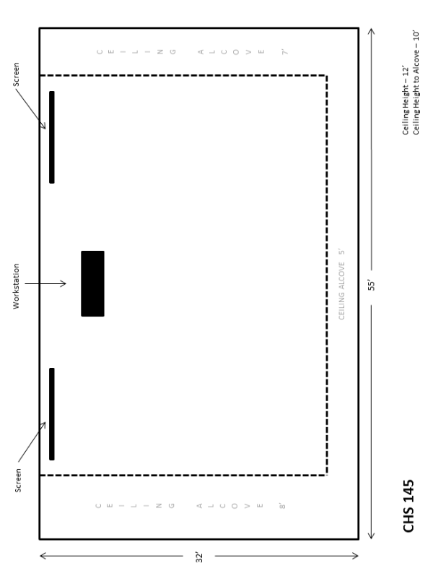

Appendix C
Grand Valley State University Center for Health Sciences
301 Michigan Street NE, Grand Rapids, MI 49503

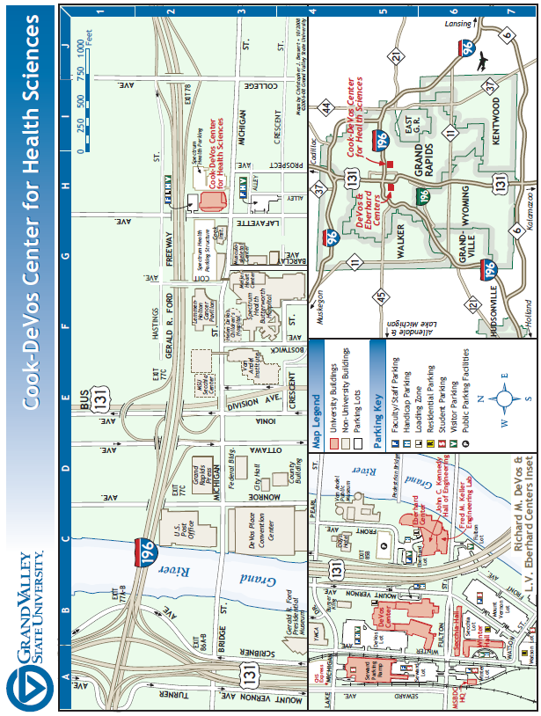
Appendix D

GVSU Supplied Equipment – NMC UC 09

Qty. | Equipment | Model | Notes
1 | Instructor Workstation | Spectrum w/Rack
1 | DVD/VHS Player | Samsung DVD-V9800
1 | Document Camera | Elmo TT-02
1 | Rack Power Strip | ETA Systems PD11SS
1 | Amplifier | Ashly SRA-120
1 | Media Processor | Crestron MP2e
1 | Multi Media Switch | Crestron C2N-MMS
1 | Touch Screen | Crestron TPS-2000L
1 | LCD Projector (north) | Epson PowerLite 84+ | For local content
1 | LCD Projector (south) | Epson PowerLite 84+ | For local content
2 | Projection Screen | Draper Electric
2 | Computer Display | Dell E198FPb
1 | Computer Tower | Optiplex
1 | Network Hub | Netgear FS105
1 | VGA DA | Extron P2-DA2+
1 | Equalizer | Ashly MQX 1310
1 | Amplifier | Toa 900 Series II
2 | Speakers | JBL
1 | Volume Equalizer Control | Crestron C2N-VEQ4
1 | S-Video DA | Kramer PT102V
1 | S-Video DA | Kramer PT102S
1 | Hearing Loop Driver | Ampetronic ILD252
1 | Hearing Loop Receiver | Ampetronic ILR2
1 | Hearing Loop Receiver | Ampetronic ILR2
2 | Hearing Loop Headphone | Ampetronic Headphone
1 | Laptop Input |  | VGA
1 | Laptop Audio Input |  | Stereo Mini
1 | Aux Stereo Audio/Video Input |  | RCA
1 | Rack Drawer | Middle-Atlantic UD3

NOTE: The listed equipment may also be upgraded prior to the system’s installation and may include HDMI compatible sources. Vendor should factor in the ability to integrate these sources as part of their proposal.

Appendix E

NMC UC 09 Room Layout

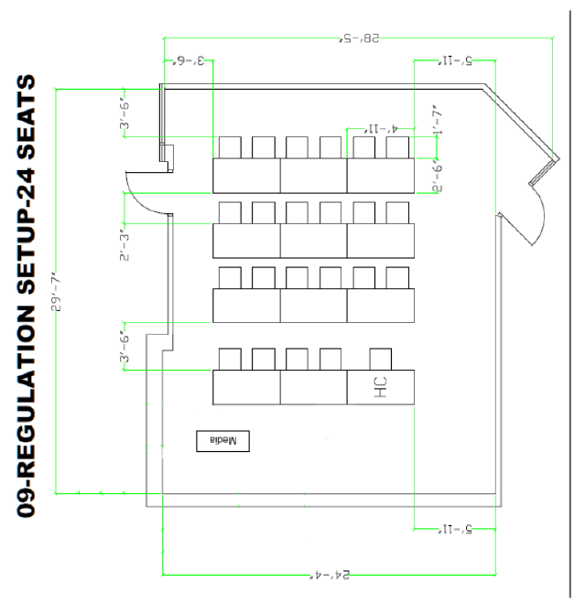
Appendix F

Northwestern Michigan College University Center
2200 Dendrinos Dr # 101, Traverse City, MI 49684

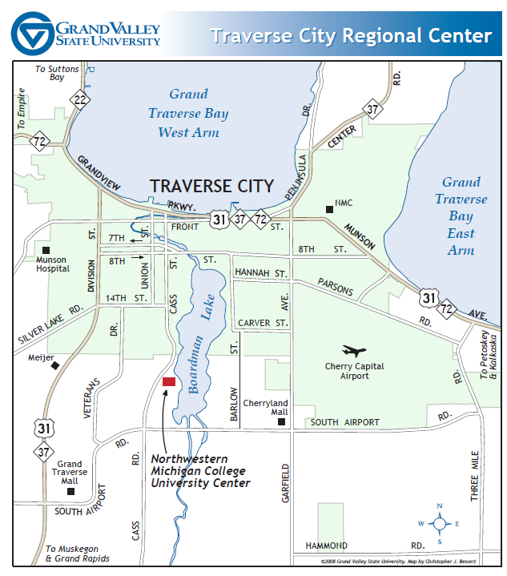

Evaluation Criteria

GVSU will select the provider deemed to be the most highly qualified to perform all of the requirements specified in the statement of need. The evaluation team will consider such factors as the ability and experience of the provider, past performance on similar requirements, willingness to meet time constraints, integration of vendor supplied system with GVSU’s existing equipment and overall system performance.

Proposal Contract

Company: _________________________________________________________________________________

Date: _________________________________________ Bid No.: __________213-35(2) ___________________

Project: Integrated Video Conference System: _____________________________________________________________

Bid opening date and time: ___Thursday, October 24, 2013 10:00 AM____________________________________

Location: _ __________ 227 Lake Michigan Hall ____________________________ ___________________

______________________ Allendale, MI, 49401__________________________________________________

Attached or included are the following proposed Contract Documents:

- Invitation to bid

- Introduction

- Statement of Work

- Specifications

- Instructions to Bidders

- Terms & Conditions

- Appendix A-F

- Evaluation Criteria

- Proposal & Contract

Bidder acknowledges receipt of the following addenda:

Addendum No. ____________ Dated ________________

Addendum No. ____________ Dated ________________

- The undersigned certifies that to the best of his/her knowledge:

There is no officer or employee of Grand Valley State University who has, or whose relative has a substantial interest in any contract award subsequent to this proposal.
The names of any and all public officers or employees of Grand Valley State University who have, or whose relative has, a substantial interest in any contract award subsequent to this proposal are identified by name as part of this submittal.
Name(s) ____________________________________________________________________

- The undersigned further certifies that their company ____ IS or ____IS NOT currently debarred, suspended or proposed for debarment by any federal entity. The undersigned agrees to notify the University of any change in this status, should one occur, until such time as an award has been made under this procurement action.

- Bidder declares the following legal status in submitting this proposal:

A partnership

A corporation organized and existing under the laws of the State of ______________________

An individual doing business as (DBA) _____________________________________________

- Bidder declares that company is at least 51% owned, controlled and actively managed by
(check all that apply):

African-American Native American Woman/Women
Asian American Multi-Racial ADA Disabled Person(s)
Hispanic American

- The undersigned proposes to furnish all items accordance with the bid document(s) listed herein, including all addenda issued pertaining to same, for the sum or sums as stated, and agrees that these document(s) will constitute the contract if accepted by Grand Valley State University via. submission of a purchase.

Proposal Sum: ___________________________________________________dollars

($______________________________)

_______________________________________________________________________________
Company Name

_______________________________________________________________________________
Address City/State/Zip Code

_________________________ _________________________ _________________________
Office Phone No. Cellular Phone No. Fax No.

__________________________________________ ___________________________________
Authorized Agent Signature Name & Title

__________________________________________ ___________________________________
Witness Signature Name

__________________________________________ ___________________________________
Tax Identification No. Date

VIII. ACCEPTANCE: This bid is accepted by Grand Valley State University

__________________________________________ ___________________________________
Authorized Agent Signature Name & Title

__________________________________________ ___________________________________
Witness Signature Name

_________________________ _________________________ _________________________
Office Phone No. Cellular Phone No. Fax No.

______38 1684280__________________________ ___________________________________
GVSU Tax Identification No. Date

