[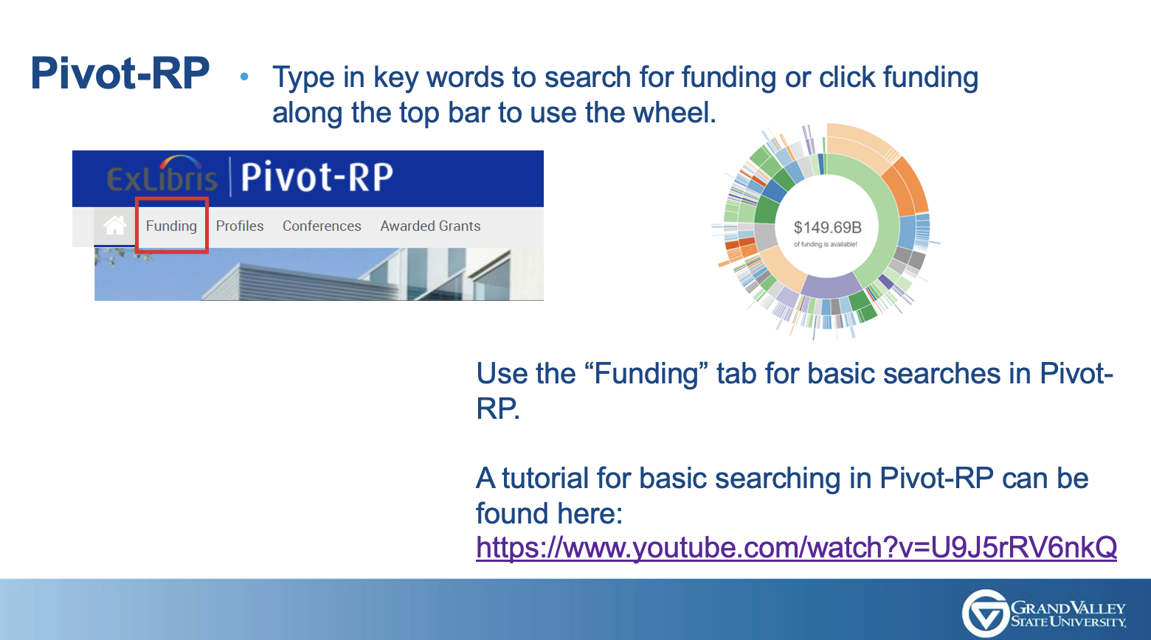](https://www.youtube.com/watch?v=U9J5rRV6nkQ)

