How to Book Travel in Lightning Updated 02-20-24

Access Lighting p. 2
Start New Travel Booking p. 3
Guest & Student Travelers p. 3-4, 7
Booking Flights p. 4-8

Filtering & Sorting Search Results p. 5
Unused Flight Ticket Credit p. 6

GVSU Travel Policy Compliance p. 6
Important Note about Unticketed Flights p. 9

Booking Hotels p. 10

Booking Car Rental p. 10
View & Manage Your Existing Reservations p. 9

This job aid will be updated with Car Rental and Hotel information.
In the meantime, view Lightning demo videos for car rental and hotels at
the Workday Job Aids & Demo Videos web page in the Finance > Travel & Expense section. And see additional information on page 8.

Lightning - Air Bookings Demo Video
Lightning - Booking Cars or Hotels Only Demo Video
Lightning - Add a Car Only Demo Video
Lightning - Add a Car or Hotel Demo Video

To Access Lighting

Go to the Okta Dashboard login page
Login with your GVSU network User ID and Password.
Click the app square that says CTM Travel. You will be taken to the CTM Portal webpage.

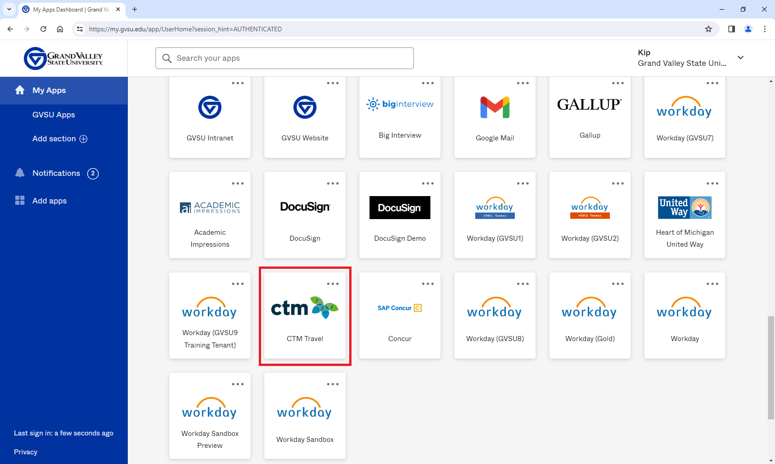

In the CTM Portal, click on the tile at the top that says Lightning.
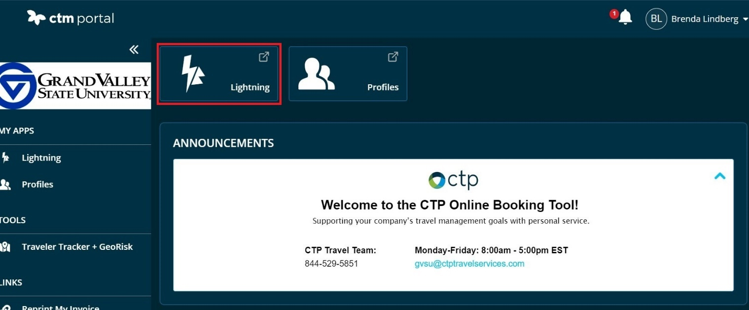
How to Book Travel in Lightning
Note: In order to use Lightning, employees must first complete their traveler profile
and add their GVSU purchasing card or declining balance card information.
(See Workday Job Aid: Lightning: Getting Started.
If you have not already done so, go to your Lightning profile and add your name in the
Arranger / Assistant field of the Administration section of your Lightning profile - see Lightning: Getting Started page 3. This allows you to add other GVSU employees to the booking if you’re booking a small group traveling together and the other travelers have made you a travel arranger for them. If you are not able to add your name, contact Kip Smalligan at 616/331-3211

To start a reservation, select the New Booking tab at the top.
To view or manage existing reservations, click the Manage Bookings tab
Check the circle buttons to select all the applicable travel services: Flight, Hotel, Car, Rail
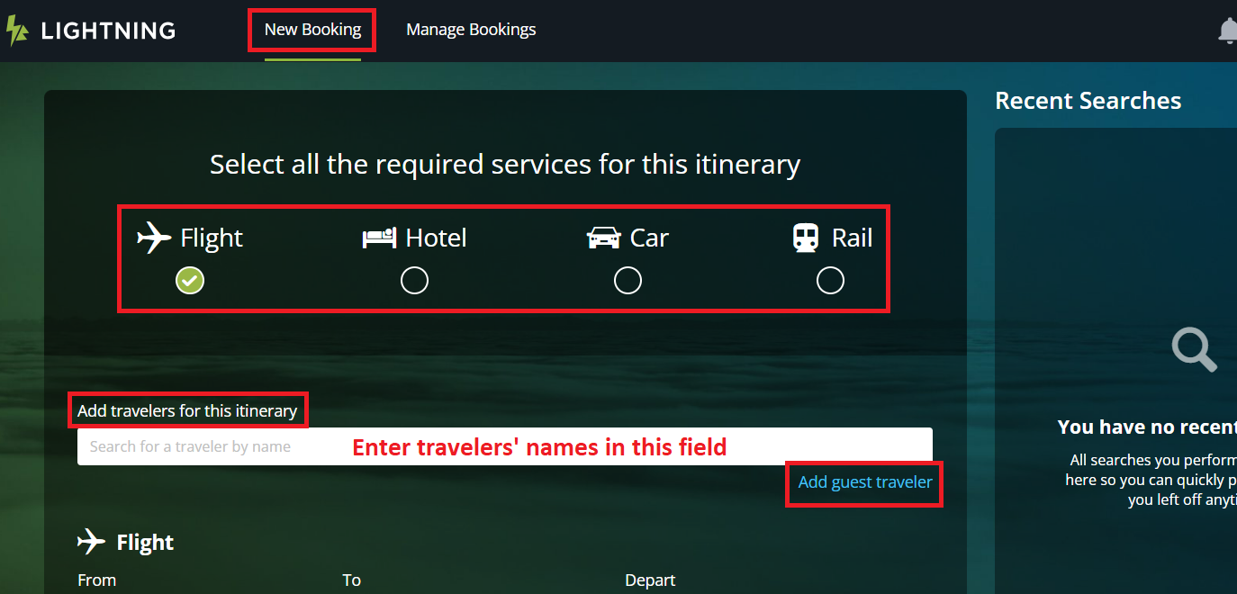
Type in the employee traveler name in the Add travelers for this itinerary field.
The employee name will pop-up; select the name to populate the field.
Note: Searching by last name is recommended; employees are listed by their legal first and last names.
Note: If you are traveling together with other employee(s) and you want to reserve for other travelers in your booking session, the other employee(s) must first complete their Lightning profile and make you a travel arranger on their behalf in their Lightning profile - see Lightning: Getting Started page 3 Travel Arrangers.
If you want to add other employees to the reservation, type in the name of the next employee and select from the pop-up. You may choose up to 9 travelers who are traveling together on the same itinerary.
To add a guest traveler or a student, click the Add guest traveler link. Then complete the required guest traveler detail fields.

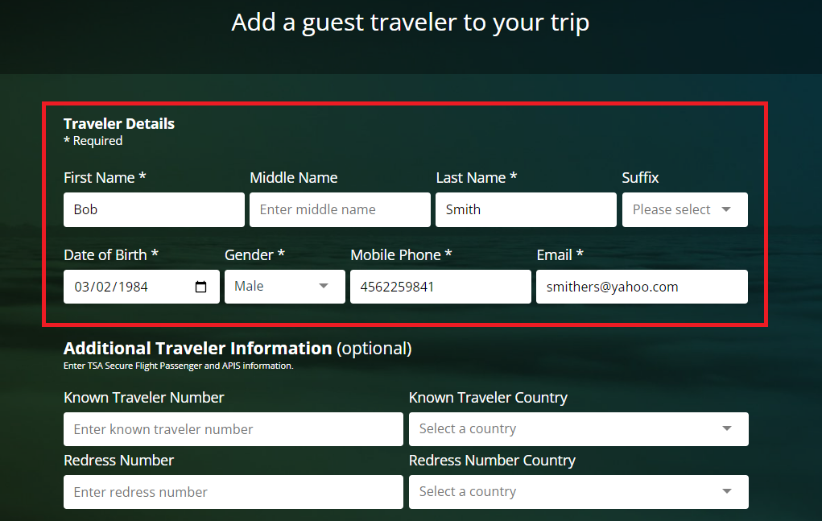
Click Save Guest Details. Your guest’s name will now appear in the Add Travelers for this itinerary field.
FLIGHTS
Enter the flight departure and destination locations by city or airport code and select in the
pop-up. Enter the date and times. You can do domestic multi-city* by clicking the Add Flight link to add another flight segment. You may add up to 5 flight segments. Click Search to display results. *International multi-city itineraries must be reserved through our CTP travel agent rather than in Lightning.
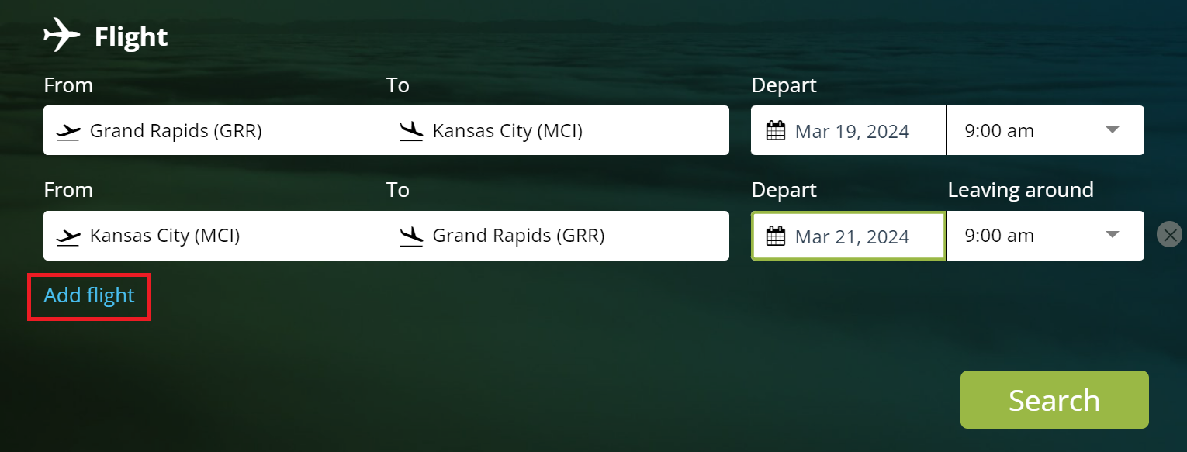

After your search results display, you can toggle between your outbound and return flights using the tabs at the top of the page.

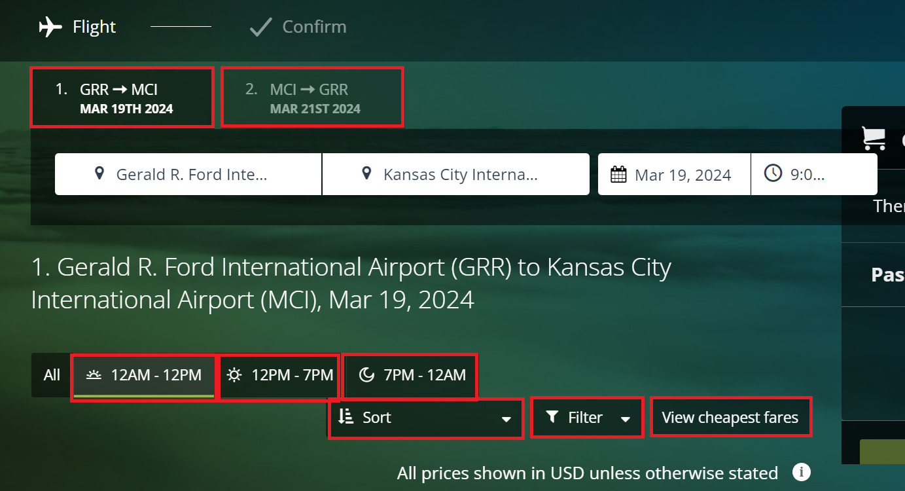

You can quickly modify the search results to view different departure times by clicking one of the three pre-set buttons for time ranges:
12:00 am (midnight) to 12:00 pm
12:00 pm to 7:00 pm
7:00 pm to 12:00 am (midnight)

You can filter the search results for:
Price
Departure
Arrival
Carbon Footprint
Airlines
Number of Stops

You can sort search results for:
Most Direct
Cheapest
Shortest
Earliest Departure
Earliest Arrival
Carbon Footprint

GVSU Travel Policy
Lightning prioritizes search results that are within GVSU’s travel policy and cost variances.
If your travel selection is not within these, you will see a symbol. Click the symbol for more information. You might have to provide a reason for that selection before proceeding with the booking.

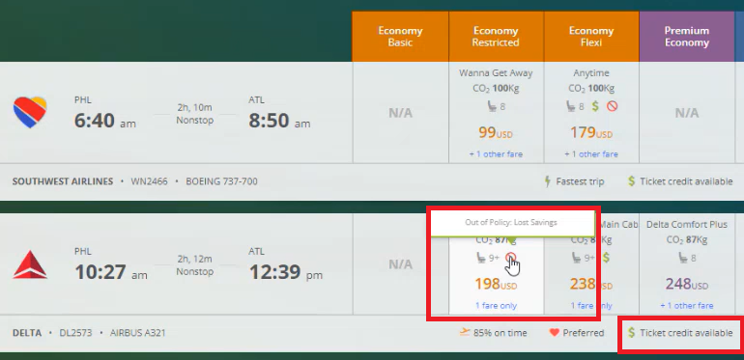

If the traveler has an unused ticket credit available to be used for a flight, it will be noted in the fare options with $ Ticket Credit Available.
You will be prompted to apply the credit at checkout.

Note: Be aware of the rules for Basic Economy type fares which are very restrictive.
Typically they do not allow any itinerary changes, seat selection is not included, passengers traveling together usually will not be seated together, no carry-on bags allowed, fee for checked bags, cancelled tickets might not be eligible for a credit, and there may be a cancellation fee. GVSU policy does not require Basic Economy fares; Main Cabin fares are also within policy.

Click the desired outbound and return trip fares to select.
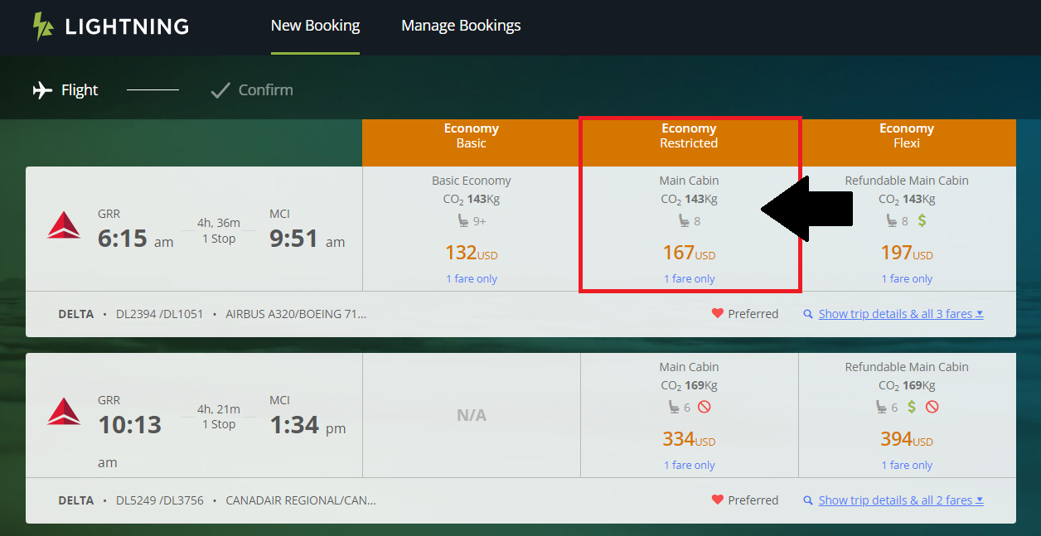

If advance seat selection is included in your fare, you may be prompted to select your seat in Lighting. If not, that can be done on the airline’s website.

If you are booking for a guest, when you get to the Confirmation page, click on the
Reference Select link.
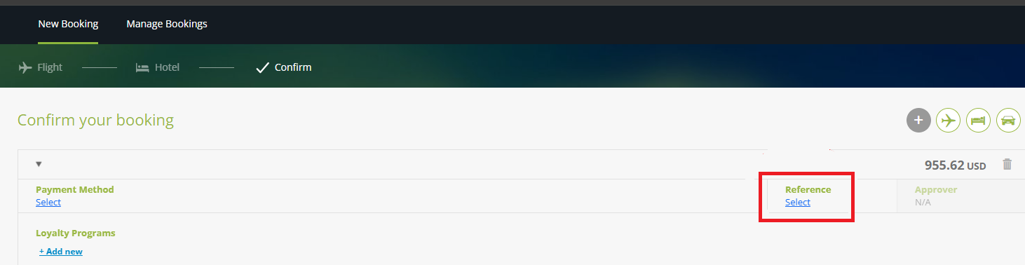
In the Company Reference pop-up, for an Employee ID and a Department, enter the username part of your GVSU email address [the part before the @] and enter your department name.
This helps ensure that the guest’s transaction will be routed to the Workday expense account of the employee who is booking the guest reservation.
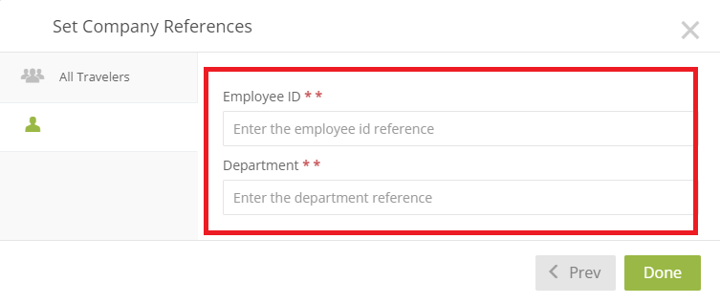

Confirm Your Booking page: You can review your itinerary and view Payment Method.
All employee and guest flights will be paid with a GVSU credit card on file with our travel agency (card ends in 5807). Your flight expense will get routed to your Workday expenses for reconciling on an expense report.

If you later decide you want to add hotel or car rental you can do so by clicking the desired service here
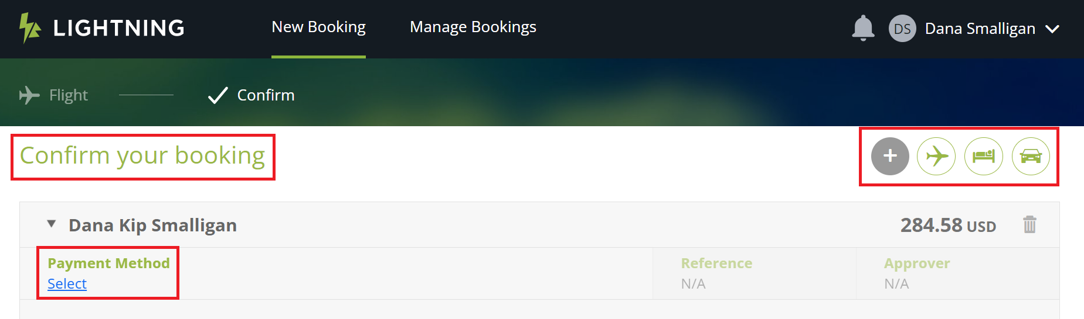

Click the View Terms and Conditions link to review the airline rules for your flight.

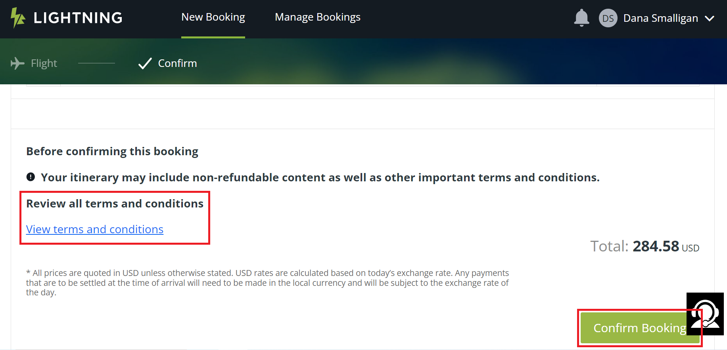
To complete the booking, click the Confirm Booking button. You will receive an email confirmation. The email might not arrive immediately as there can be a delay in ticketing.
You can also view your reservations by going to the Lighting home page and click Manage Bookings at the very top; look in the Booking Status section in the lower left (see next page)

You can view your existing reservations by going to the Lighting home page and click
Manage Bookings at the very top; then look in the Booking Status section in the lower left.

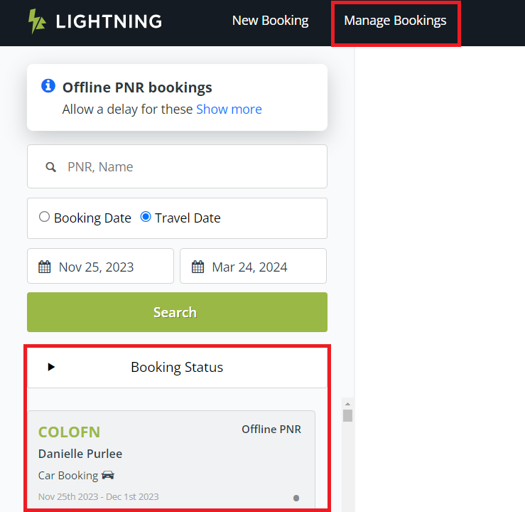

*** IMPORTANT ***
Email or Voice Message Regarding Unticketed Flight from our Travel Agency
If you receive an email or voicemail from our travel agency, Collegiate Travel Planners (CTP), stating that your flight was not ticketed it means that you do NOT have a reservation even if you have a confirmation number. This is caused by a decline of our credit card on file with the travel agency or other technical issue with ticketing. Call our travel agency right away to get corrected: Collegiate Travel Planners (CTP) at 844-529-5851

This Job Aid will be updated with Car Rental and Hotel information in the near future.
In the meantime, please view Lightning demo videos for car rental and hotels at
the Workday Job Aids & Demo Videos web page in the Finance > Travel & Expense section

Lightning - Air Bookings Demo Video
Lightning - Booking Cars or Hotels Only Demo Video
Lightning - Add a Car Only Demo Video
Lightning - Add a Car or Hotel Demo Video

HOTEL

Note: The credit card in your Lightning profile will hold your hotel reservation. But you will still need to present a credit card at check-in to charge your room and any incidental expenses.
If you are booking a hotel for a guest, and GVSU is paying for only the room and tax, and you will not be present with the guest at check-in to provide your credit card, you will need to contact the hotel directly and request to put a credit card on file. The hotel will provide you with a credit card authorization form. On the form, authorize the card for room and tax.
The guest will still need to present a credit card at check-in to pay for any incidental expenses (movies, etc.).

If you are booking a hotel for a guest and GVSU is paying for the guest, and you do not want the guest to have to present a credit card at check-in or check-out (e.g. students or VIPs), you will need to contact the hotel directly and request to put a credit card on file. The hotel will provide you with a credit card authorization form. On the form, you must authorize for all charges.

CAR RENTAL
Note: See the GVSU Vehicle Rental Procedures and GVSU Driving Vehicles websites for important and helpful information regarding GVSU rental policies and procedures

Enterprise and National are GVSU’s preferred rental companies as we have a contract with them. Travelers should use Enterprise or National unless they cannot meet your needs.
Search results for Enterprise and National include GVSU’s contract rates.

The credit card in your Lightning profile will hold your car rental reservation but you will still need to present a credit card at check-in to charge your rental.

