Lightning Online Booking Tool: Getting Started
How to Access Lightning and Complete Your Traveler Profile

Go to the Okta Dashboard login page
Login with your GVSU network User ID and Password.
Click the app square that says CTM Travel. You will be taken to the CTM Portal webpage.
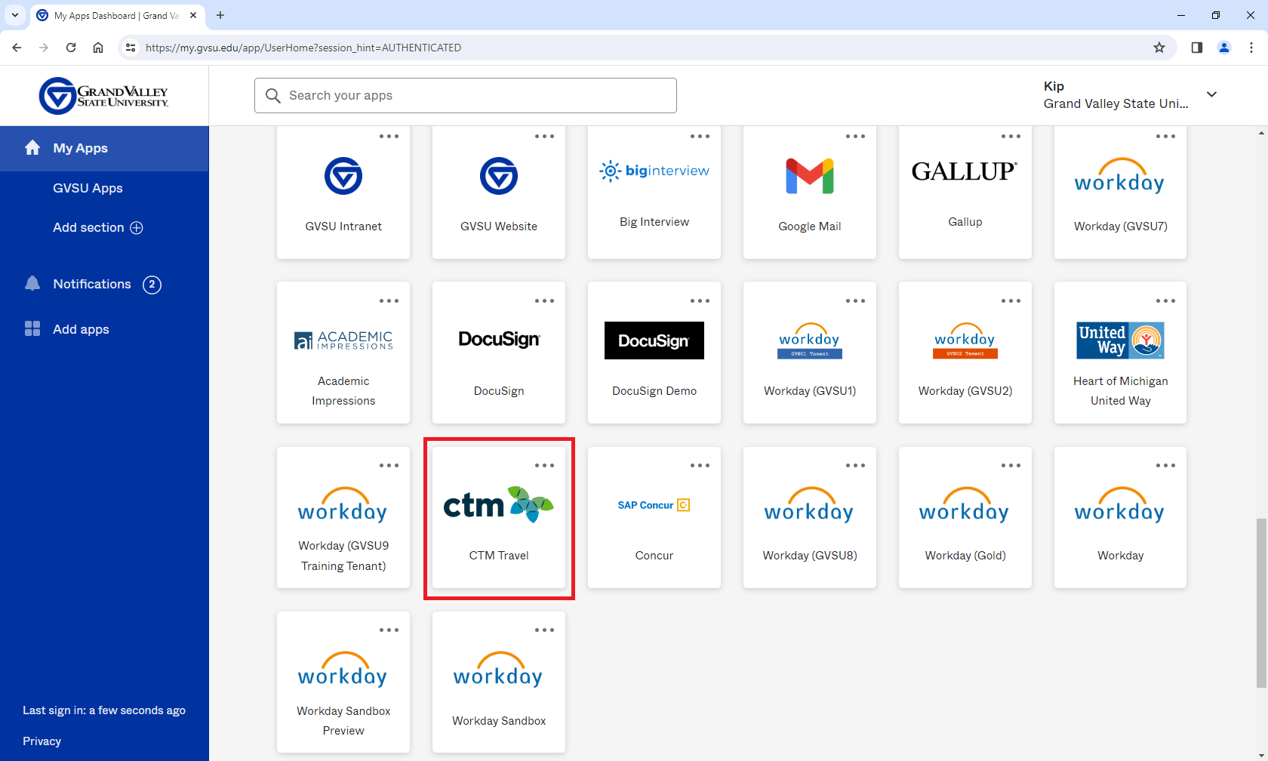
In the CTM Portal, click on the tile at the top that says Profiles.
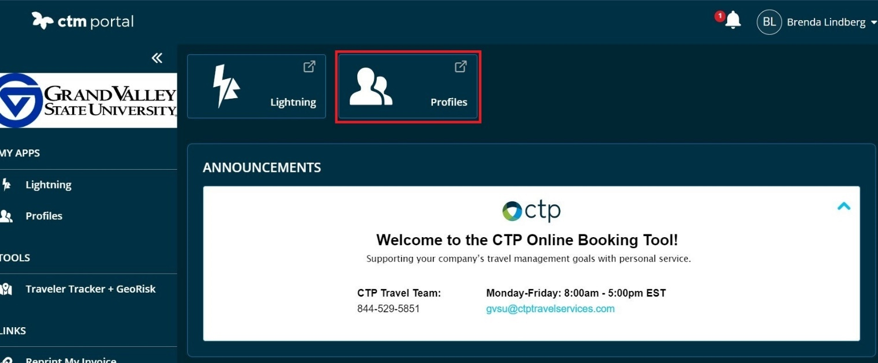

A privacy statement will appear. Scroll down to the bottom of the statement and click Accept.

You will see either a My Profile or Travelers menu at the top left of the Welcome screen.
Click the one you have. That will take you to the Profiles page.
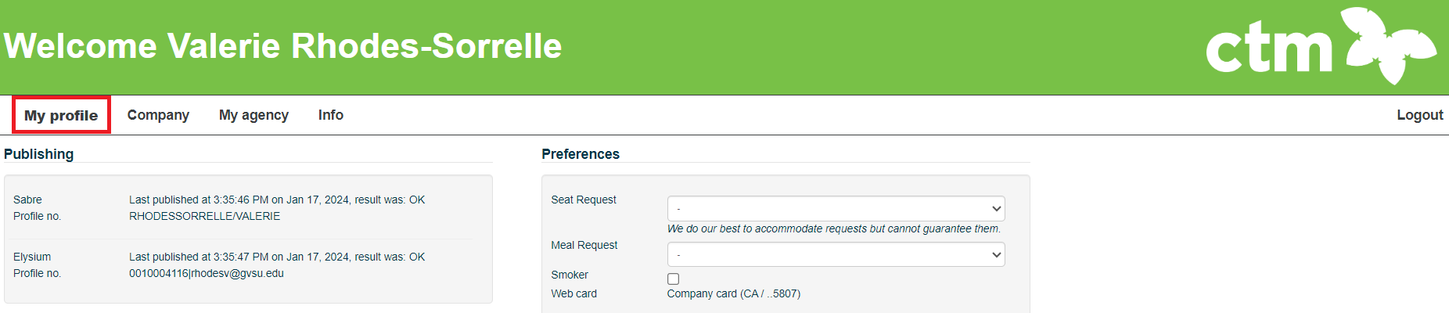
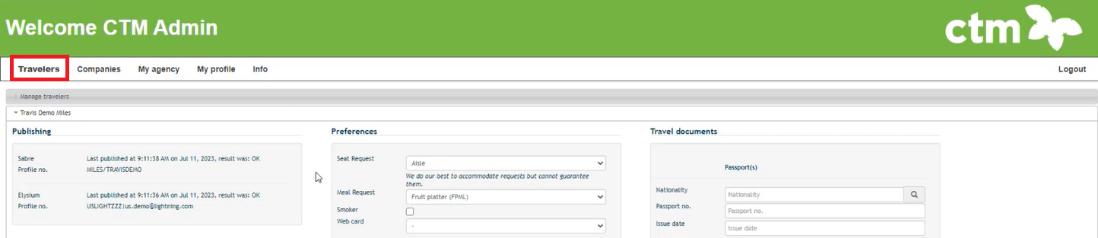

Some of your information is already added to your profile. Verify that it is correct.

GENERAL SECTION

Required Fields
First & Last Name as it appears on traveler’s government ID
Date of Birth
Gender
Citizenship
Email address for each traveler
Phone Number

*** IMPORTANT ***
Credit Card Information
You will need to add your GVSU purchasing card or declining balance card information in order to make reservations for hotel and car rental.
To add your card, click the Add New link.
Do not check the checkbox Use as Form of Payment (Air Tickets)
Click Save in bottom left corner.
Note: Airfare for employees and guests is paid with a GVSU credit card on file with our travel agency. That card number ends in 5807. You will see that card number applied for your airfare when you reach the Method of Payment step

ADMINISTRATION SECTION
*** IMPORTANT ***
In the Arranger / Assistant field, type in your name until you see your name pop-up.
Click on your name to populate the field.
Also click the Primary Arranger checkbox.
Click Save in the lower left part of the web page..
If you are not able to add your name in this field, contact Kip Smalligan 616/331-3211
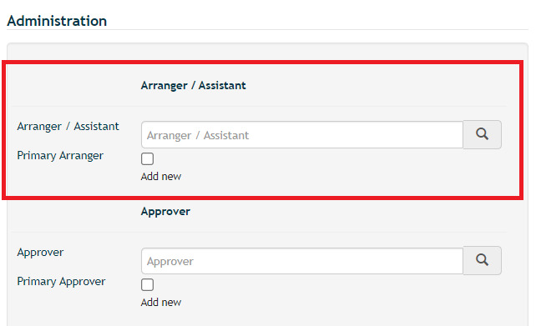

Travel Arrangers
You can select another employee(s) to be your travel arranger to be able to book travel on your behalf. Arrangers can access your entire profile and book and change your reservations.
To add a travel arranger, click the Add New link.
Type in the name of the travel arranger in the Arranger/Assistant field. Their name will appear in a list. Select their name.

If you would like the arranger to be your primary arranger, click the Primary Arranger checkbox. Primary arrangers receive all communications from Lightning and CTP travel agency for the traveler regardless of who booked the travel. Non-primary arrangers will only receive communications if they booked the travel. You can have only one primary arranger.
To add more travel arrangers, click the Add New link and repeat above steps.
To delete a travel arranger, click on the red X to the right of the arranger’s name.
Click Save in bottom left corner.

If you are a travel arranger for another employee, see additional information on page 5.

PREFERENCES SECTION

Frequent Flyer
State the airline and your frequent flyer number.
You can also save by airline alliance OneWorld or Skyteam or Miles and More.
Click Add New link to add more airlines.

Hotel Guarantee
If you have more than one credit card in Lightning, you can choose which one will be used by default to hold hotel reservations.

Hotel Loyalty Program
Select by individual hotel OR if you see a hotel brand followed by (all) -- for example Marriott (all) -- that means your loyalty number will apply to all the other hotels brands under that parent brand.
Guarantee Rental Car
If you have more than one credit card in Lightning, you can choose which one will be used by default to hold hotel reservations.

Car Rental Loyalty Program – select the rental company
Click Save in bottom left corner.

TRAVEL DOCUMENTS SECTION
Passport, Visa, TSA Pre-Check or Redress number.
Travel document information is sent to your airline and the TSA.

Click Save in bottom left corner.

Note: To ensure that profile changes take effect in Lighting, the affected user should close their CTM Portal browser tab and then re-open it from their Okta dashboard (CTM Travel app)

If you are a travel arranger for another employee(s):
1. You can access their travel profile by going to Okta and accessing the CTM Portal page, select Profile. On your Profile Welcome screen, click Travelers.

Click Manage Travelers and enter the name of the employee you want to view in the search field and click Search. Note that employees are listed by their legal name so it may be easier to search by their last name.

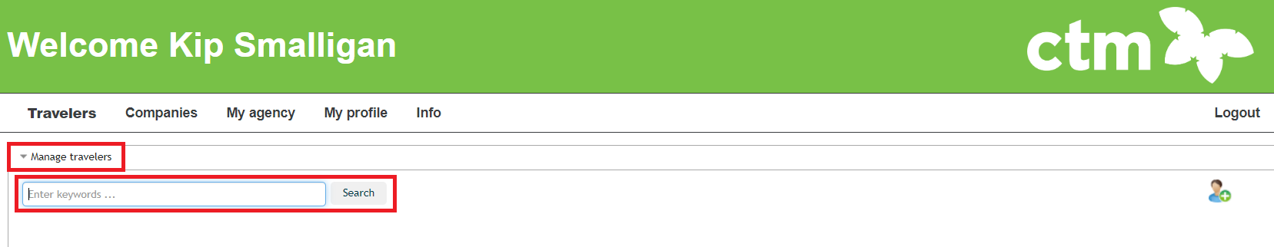

To return to your own profile, search by your name.

2. To see all users who have made you a travel arranger on their behalf
In your profile welcome screen, click Travelers, click Manage Travelers, leave the search field blank, click Search. A list of those who you are a traveler arranger for will appear.

Note: To ensure that profile changes take effect in Lighting, the affected user should close their CTM Portal browser tab and then re-open it from their Okta dashboard (CTM Travel app).

To exit the profile page, close the “CTM Profiles” web browser tab.
To return to the CTM Portal, click the “Smart Portal” web browser tab.
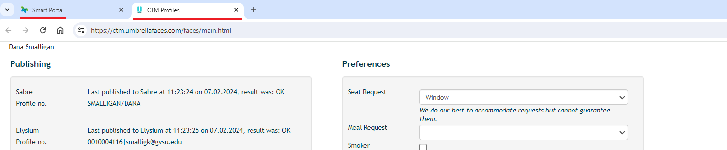

To access Lightning, in the CTM Portal click the Lightning square at the top.
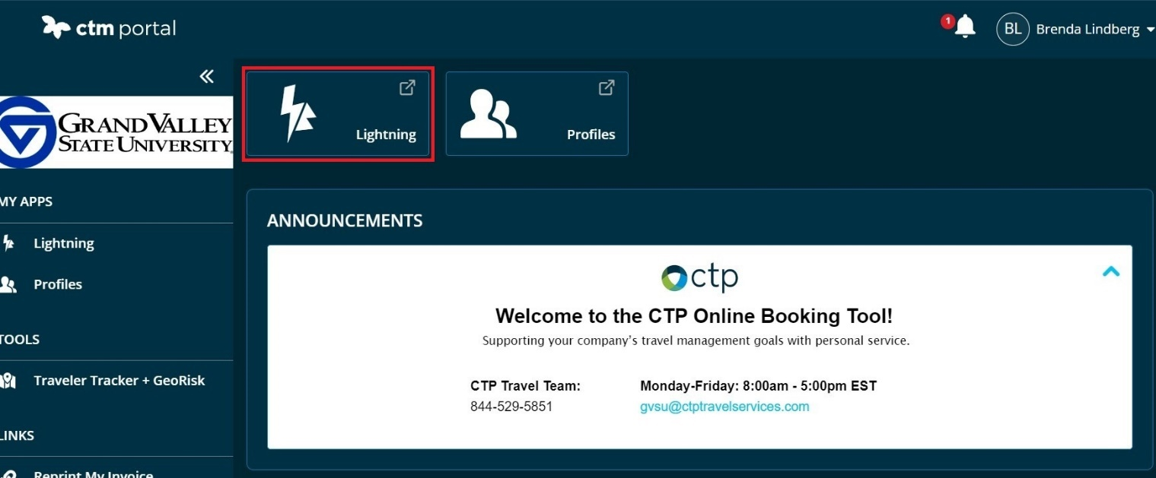

See the job aid How to Book Travel in Lightning in the Workday Job Aid & Videos web page.

Questions about Lightning?
See Workday Job Aids for Finance > Travel & Expenses
See University Travel Management web page
Contact Kip Smalligan 616-331-3211

Updated 02-26-24

