Bluescape Updated Call Feature

At the top of the Bluescape home screen there is a new feature to start a meeting without being in a workspace.

Click “Start new meeting” at the top of the Bluescape home screen

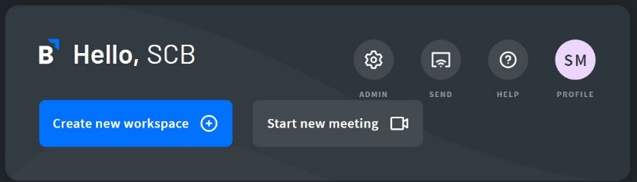

Call Setup Screen

Left most icons: Turn on/off your mic and camera

Gear icon: See your mic and camera settings

Phone icon: See the meeting information

Right most icon: Copy meeting link
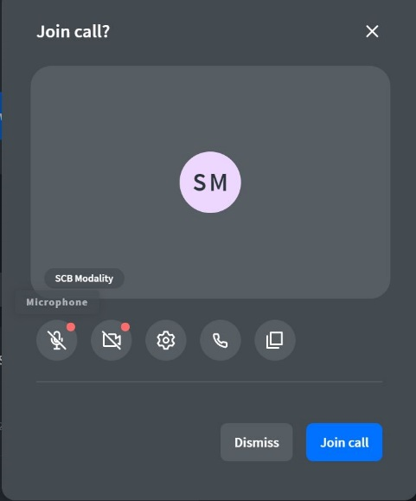

- Click “Join call” when you’re ready to start your meeting
- Top left triangle icon: adjust call view (minimize, grid, list)
- Top right dot icon: call settings

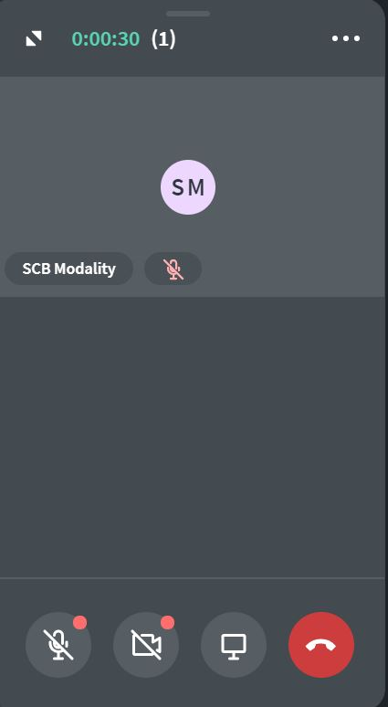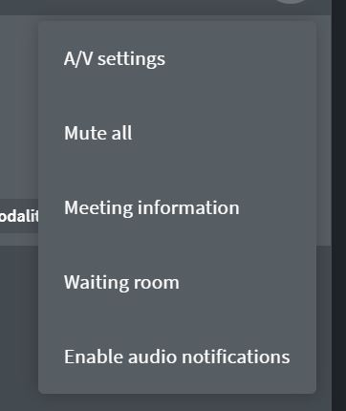

- Left most icons: turn on and off camera and microphone
- Square icon: share screen feature (navigate other call members through different workspaces)
- Far right icon: end call

Begin your bluescape meeting and navigate through your different workspaces.

