Gene flows between hunter-gatherer and farming groups in Stone Age central and eastern Europe
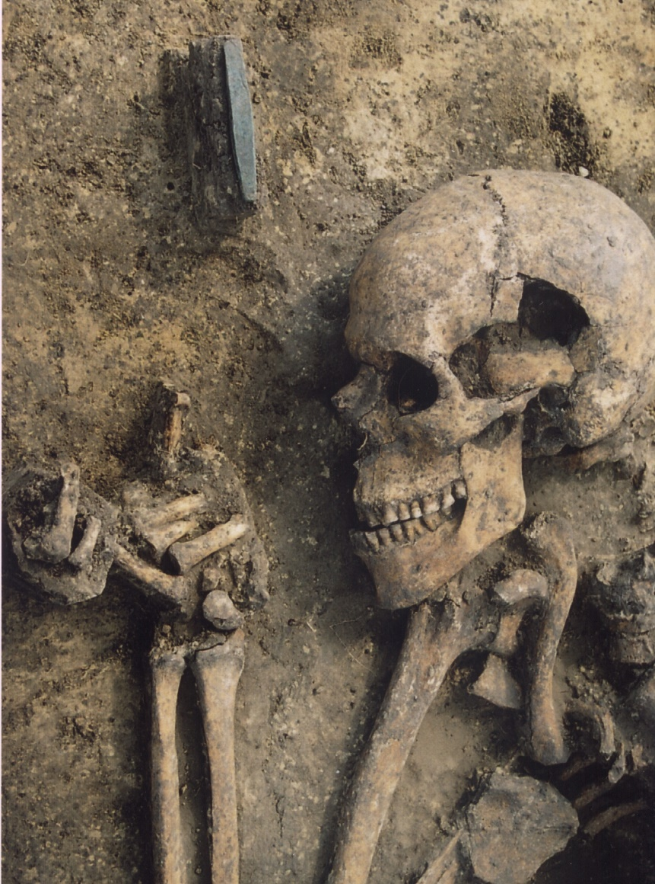
A photo of the individual Książnice 2 from Poland, included in the new study. Photo: Stainslaw Wilk
A new DNA study from Uppsala University and an international research team is published in the journal Communications Biology on August 9. The study refines the picture of how different groups during the European Stone Age mixed, but also how some groups were isolated. The study produced new genetic data from 56 Central and Eastern European individuals from the Stone Age. The study links different stages of cultural and genetic development over several thousand years. "To carry out such studies, a broad interdisciplinary discussion is required. In this study, it has been exceptionally fruitful," says Tiina Mattila, the study's first author and population geneticist.
Over the past 15 years, previous DNA research has built a picture of European Stone Age history piece by piece. Before agriculture spread to Europe, in different parts of Eurasia there were different groups of hunters and gatherers, who also mixed with each other. This study shows that the mixing of these hunter-gatherer lineages was strongly linked to geography.
Several previous DNA studies of European prehistory have also shown that the spread of agriculture was strongly linked to gene flow from Anatolia. This group was very different - genetically and culturally - from the European hunter-gatherers. However, agriculture spreads in different ways in different geographical areas. This led to the people groups being mixed in different ways in different parts of Europe. "These differences in the mix of lineages and cultures can tell us about the relations between different groups," says Tiina Mattila.
The new study also looked at close relatives. "Joint graves are often assumed to be family graves, but in our study this was not always the case," says Helena Malmström, archaeogeneticist at Uppsala University. This shows that already during the Stone Age, other social factors also played a role in burial practices.
A comprehensive picture of the genetic history of Stone Age Europeans has emerged. This study adds further details to this puzzle. "We can show that some parts of Europe - such as the area around the Dinpro River delta - were populated by a group of hunters and gatherers for many thousands of years. This despite the fact that many other parts of Europe changed their way of life in connection with the arrival of new groups who produced food by tilling the soil." says Mattias Jakobsson, professor of genetics at Uppsala University.
The study also showed the arrival of new genetic ancestry to the Middle Dnipro Valley at the end of the 5th millennium BCE. The bearers of this ancestry became known as the Yamna culture by the end of the 4th millennium BCE. The Yamna people ushered in new economic and political structure, along with a cultural worlview and a group of languages stemming from one common source, to all corners of Europe and beyond.
Link to the publication: https://www.nature.com/articles/s42003-023-05131-3

Tiina Mattila (English, Finnish), Uppsala universitet, email: tiina.maria.mattila@ebc.uu.se
Anna Juras (English, Polish), Adam Mickiewicz University in Poznań
Mihai Netea/Andei Soficaru (English, Romanian)
Alexey Nikitin (English, Ukrainian), Grand Valley State University, email: nikitin@gvsu.edu, phone: +1-616-331-2505
Helena Malmström (English, Swedish), Uppsala universitet, email: helena.malmstom@ebc.uu.se, phone:
Mattias Jakobsson (English, Swedish, Danish), Uppsala universitet, email: mattias.jakobsson@ebc.uu.se, phone:

