How to guide 2024
Using the International Application Portal

usc.edu.au

This guide will help you prepare, finalise and submit an online application to the University of the Sunshine Coast (UniSC) Australia as an Exchange student. Before you start, we suggest preparing the following information and documents:
- the email address you wish to register and receive application updates to
- your passport or identification document
- your academic transcripts (certified transcript or academic documents).
Congratulations, you are one step closer to your study abroad adventure!
Follow this how to guide to begin your application.
Register
Visit www.student-usc.studylink.com and click “Register”.
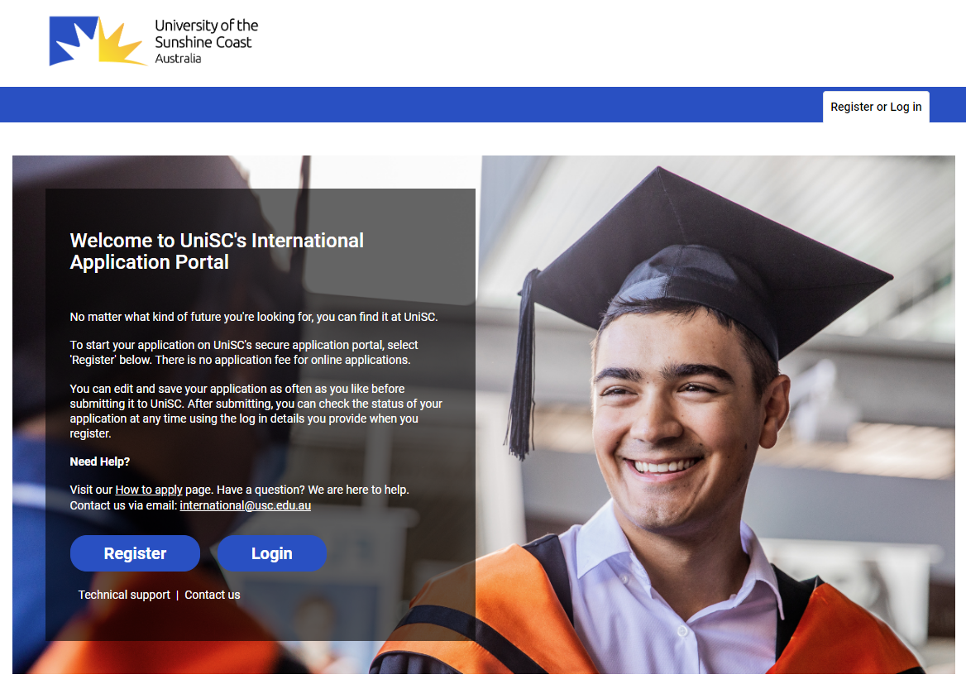

Complete the registration page:
- Citizenship status = international student
- Complete your full name (as per your passport), email address and create a password (Note: remember the email and password you use for access later on)
- If you are not in Australia indicate “No”
- Indicate “No” for Higher Degree by Research (this is only for PhD students)
- Select your nationality (as per your passport)
- Click “Register”
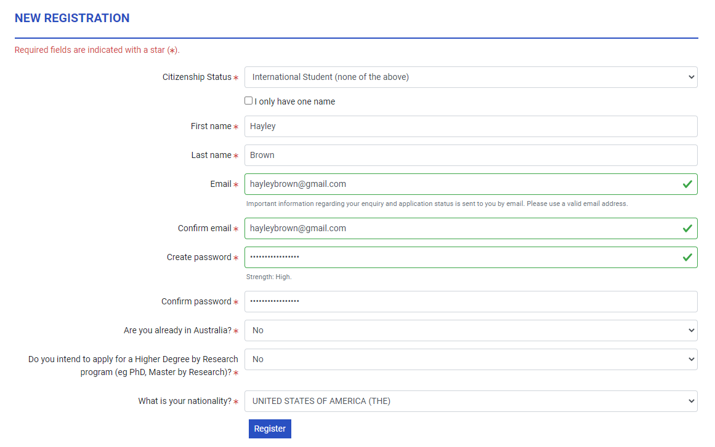
Select your program
Exchange will not appear in the search bar. Therefore as an Exchange student, you are required to apply for the ‘Study Abroad’ program initially. There will be further steps later in this guide to assist with converting you to your rightful Exchange program.

Search “Study Abroad Undergraduate” and leave Award Type as “Any”.
Click “Apply Now” for the Study Abroad program.
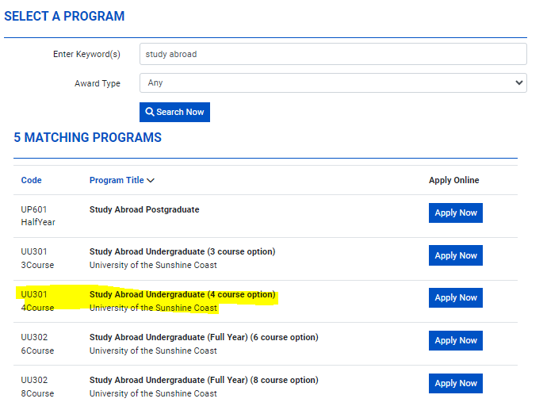

Before you start
Read the preparation and eligibility criteria, tick “Yes” and “I am ready to apply!”
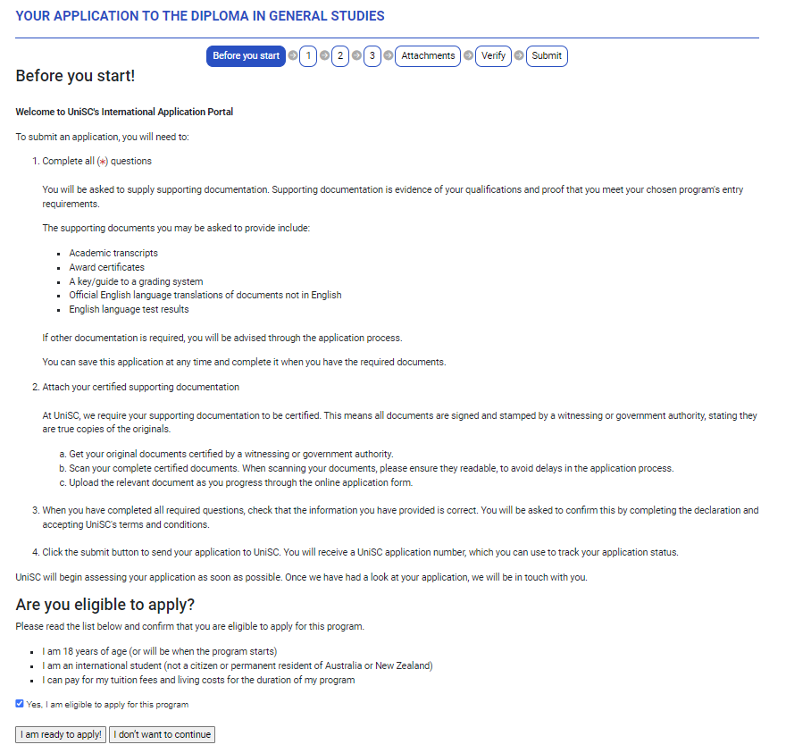
Step 1 - Personal Details
Some details will auto-fill from the registration page. Complete the remaining fields:
- Your preferred title
- Middle Name (if applicable)
- Gender/sex
- Date of birth
- Confirmation of 18 years or older
- Birth country
- Language spoken at home

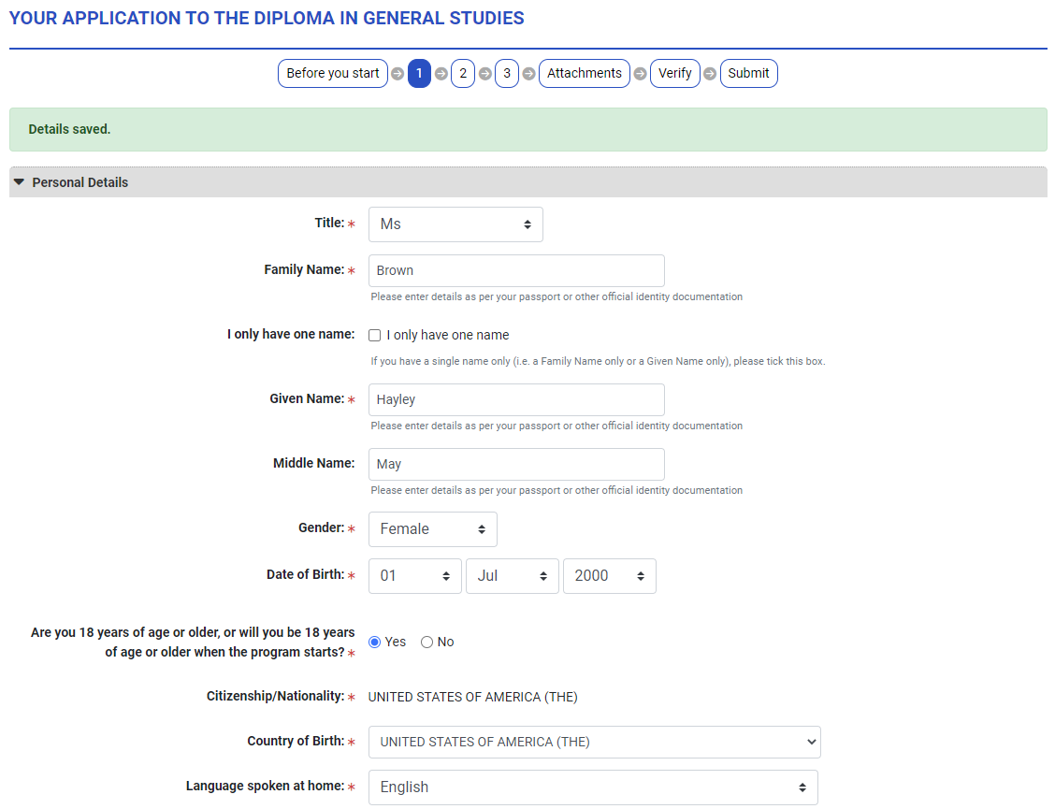

Contact details
Complete:
- Mobile number (the area code for the US is 1)
- Your current address and indicate “Yes” to permanent address. If your permanent address is your parent’s address and your current address is your dorm on campus you could indicate “No” and add your parent’s address as well.

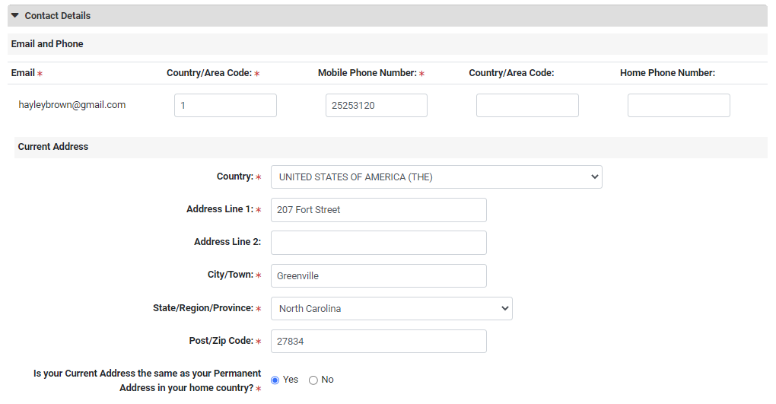
Passport and Visa Details & English Language Proficiency
Complete:
- Enter your passport number and expiry date and indicate the type of visa you are applying for e.g., Student visa. Upload a copy of the personal details page of your passport. If you do not yet have a passport indicate “No.” You can add any document to your application after submission.
- Indicate if English is your first language and click “Save & Continue.”
Note: you can “Save & Close” if you need to pause your application and come back to it later.

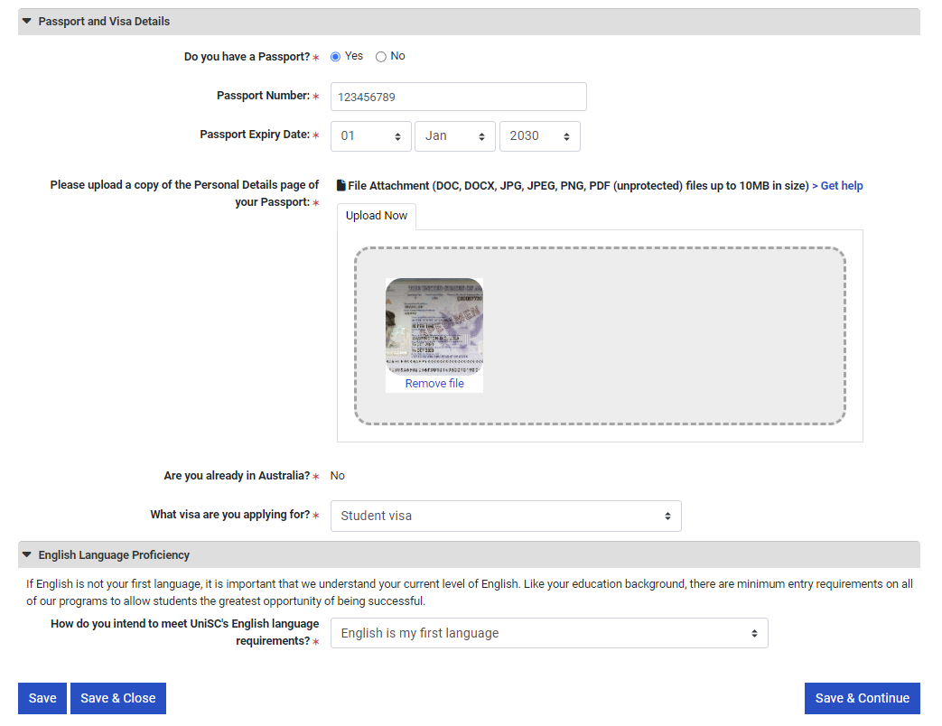
Step 2 – Program Selection
Choose the semester & campus via the “Select Intake” button.
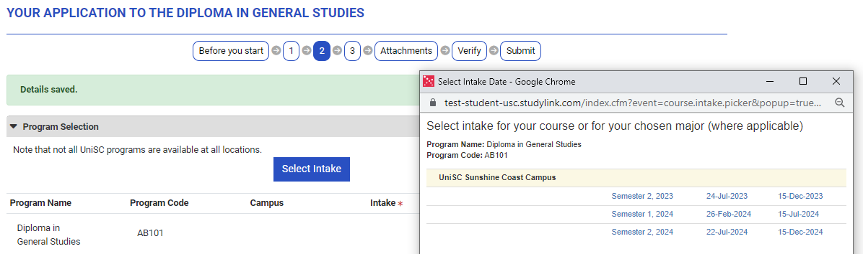

Note: Semester 1 is February – June (Spring), Semester 2 is July – November (Fall).
To choose the courses you would like to study at UniSC visit: www.usc.edu.au/study/courses-and-programs/courses/study-abroad-courses
Ensure you select the intake you are applying for as some courses have specific semester availability.
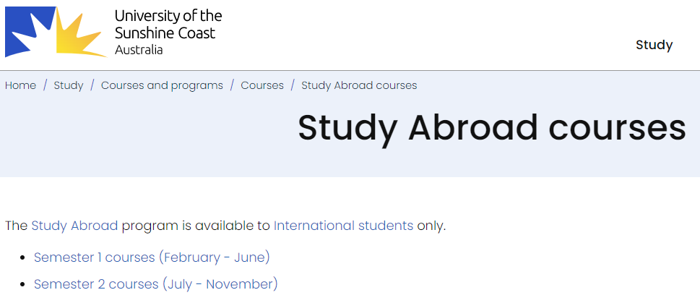
UniSC courses are categorized by the school faculty. For the Diploma in General Studies, you can choose any course from any faculty:
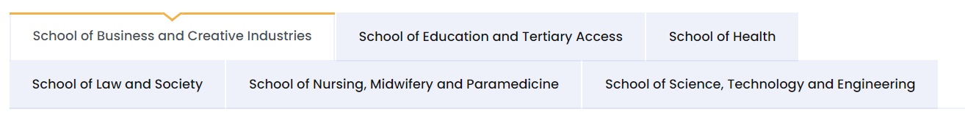
Some courses do not have prerequisites and you automatically meet the requirements to study those courses. Some courses do have prerequisites and UniSC will need to assess your eligibility to study those courses. Regards of prerequisites list your chosen UniSC courses including the course code, title, semester of offer and home institution approval.

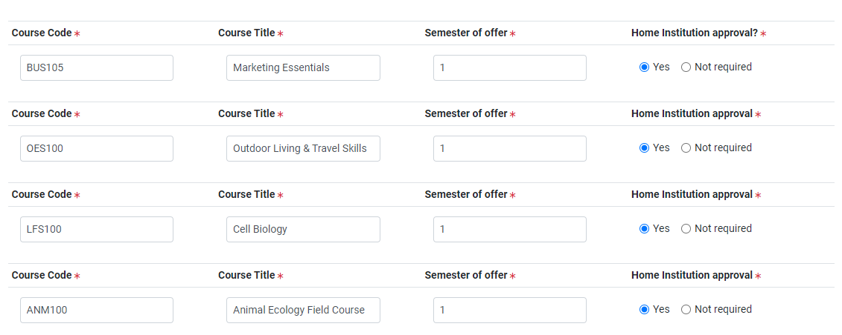
Note: If you are unsure, or are waiting for home institution approval, simply put to be confirmed “TBC” in course code, title and semester. You can always add your course choices later.
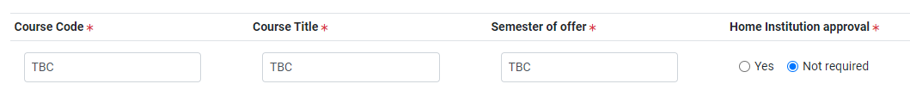
Previous Studies
As you are from a partner institution select “Post-Secondary Education (e.g., TAFE or University).
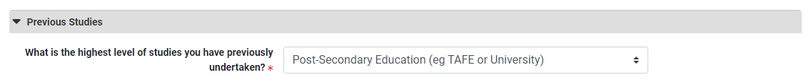
University/Post-Secondary Education
Enter the name of your current qualification. This could be your major e.g., “Bachelor of Arts,” or if you have an undeclared major simply list the level of your qualification e.g., “Bachelor.”
Search for your home institution by selecting the country first and then the name of your home institution.

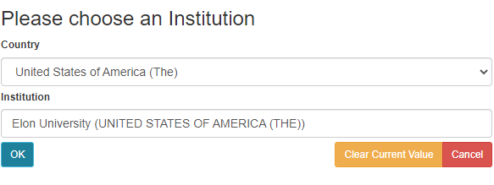
Complete the Language of Instruction, when you intend to finish your studies (this can be an estimate) and attach a copy of your certified transcript. If you are unsure whether your transcript is certified your UniSC Admissions Officer will check once, you submit your application. If it is not certified, we will request your transcript directly from your home institution.
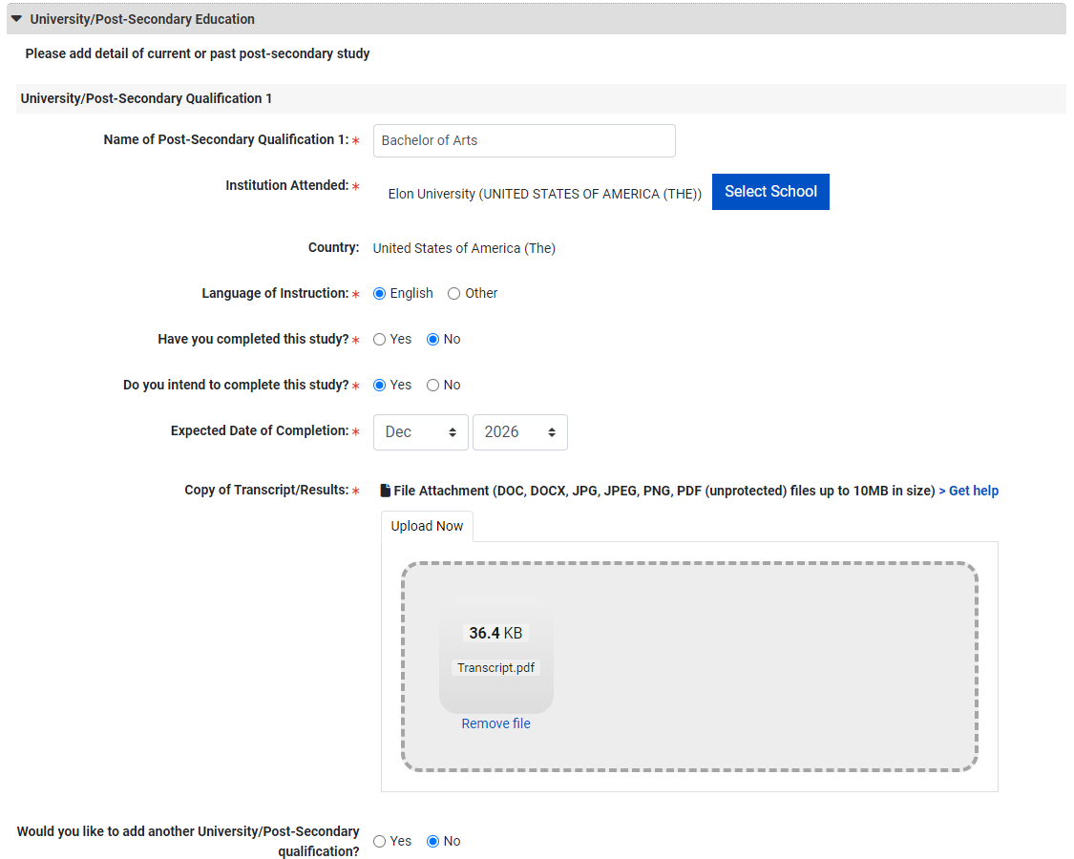

Current Study at a Partner Institution
Tick “yes” and type the name of your institution.
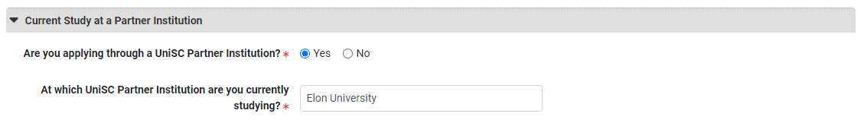
3 - Overseas Student Health Cover (OSHC)
Depending on the arrangement with your home institution OSHC may be included. As the Australian Government requires OSHC insurance coverage for Student visa holders we can arrange this for you. Even if you have health insurance at home, unfortunately the Australian Government does not recognize this. If you are unsure, select “yes – please arrange my OSHC” with “Singles Cover,” and we can arrange this for you.
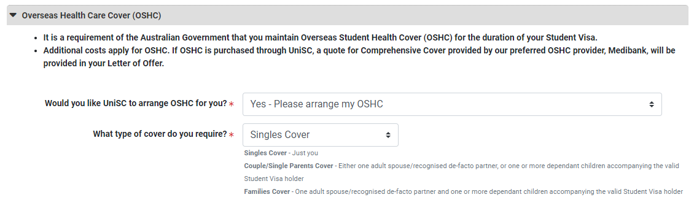

Support Services
If you do not have a disability, impairment of long-term medical condition tick “No” and if you do, tick “Yes.”
If “Yes” is indicated, further options will appear. Select the most relevant option and list any additional information you would like to share.

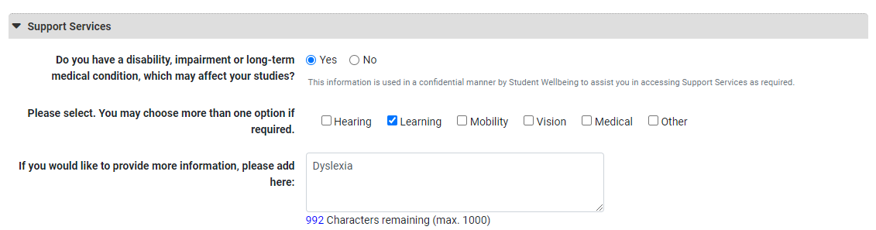
Applicant Declaration
Read through the applicant declaration and tick the relevant boxes.
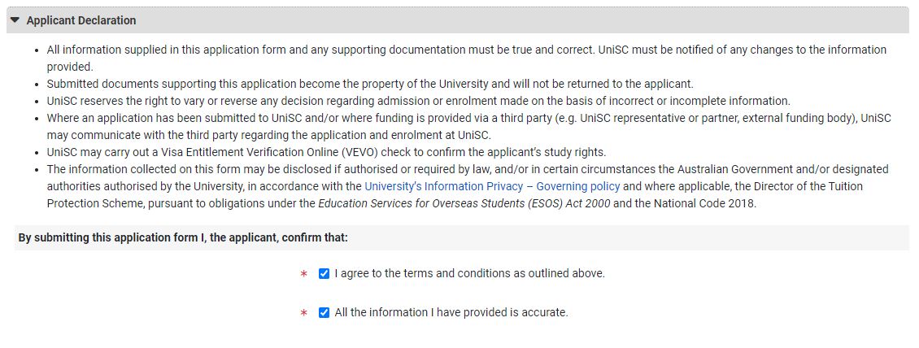

Attachments
Review your attachment and add the comment “UniSC nominated Exchange student”
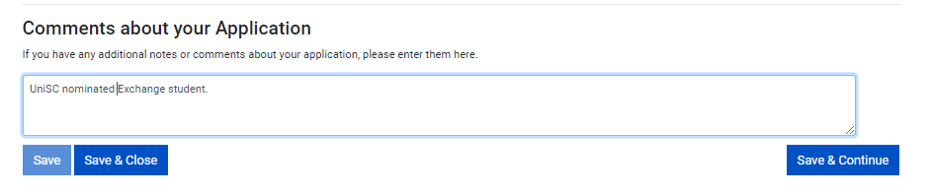
Click “Save & Continue.”
Submit
You’re nearly there! Review the information and ensure that your program is correct and take note of your Application Number. Simply add “app-“ to the beginning of your Application Number followed by @usc.studylink.com. E.g., app-50036941@usc.studylink.com

This is your unique Application Email. You can directly contact your assigned Admissions Officer or send documents to add to your application.
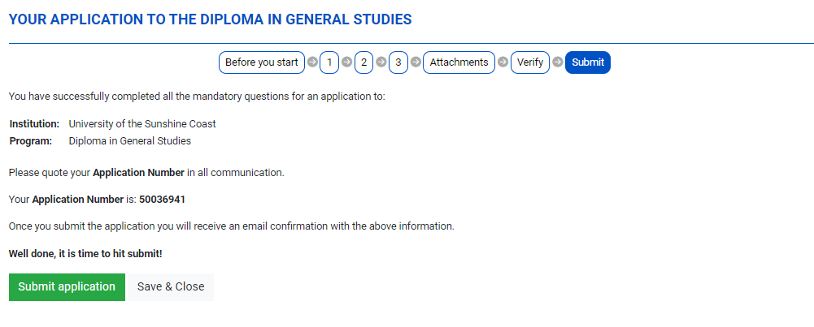

Press the green “Submit application” button to receive your “Application Submitted” confirmation. You should also receive a confirmation email to the inbox of the email address you registered with.
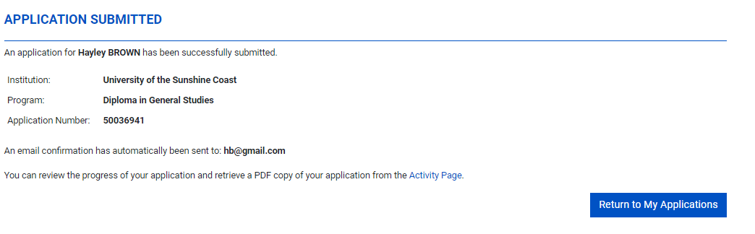
By submitting your application online, you have created an account in the portal. Visit www.student-usc.studylink.com to log in with the email address you signed up with. Here you can check the status and progress of your application, contact UniSC or upload additional documents. If you enquire about your application, please quote your application number.
Congratulations! You’re one step closer to beginning your studies in Australia and your UniSC Admissions Officer will be in contact soon.

